**JDK** – It includes everything needed to **develop and run** Java programs. (JRE + compiler (javac) + debugger + developer tools)

**JRE**– It provides a runtime environment for executing java code (JVM + standard libraries + other resources)

**JVM** – A virtual machine that runs Java bytecode. It is Platform-dependent (each OS has its own implementation). It converts the bytecode into machine code that the specific operating system and hardware can understand.

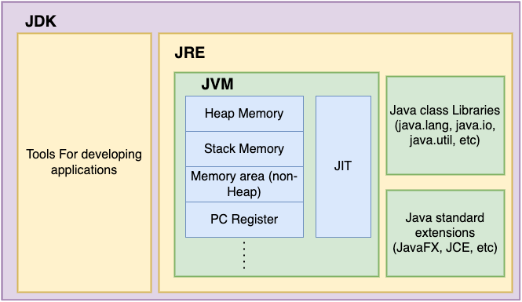 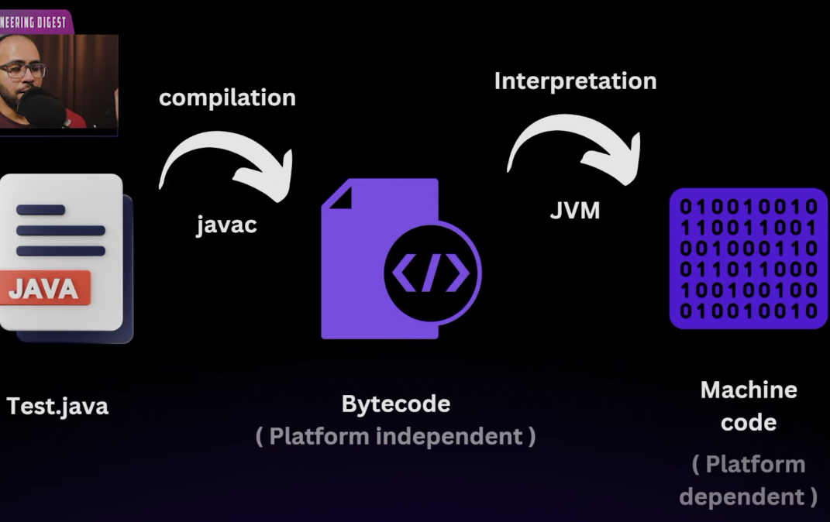

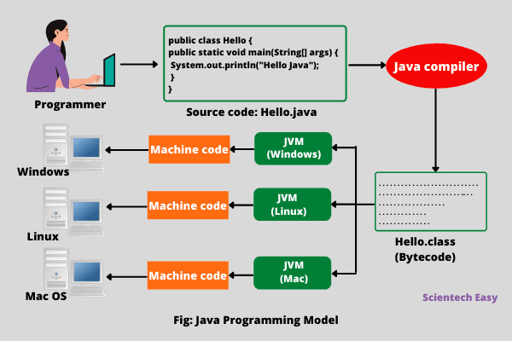

**javac test.java** 🡪 produce bytecode in test.class file

**java test** 🡪 jvm converts bytecode to machine code and run it.

Inside JVM –

* **Interpreter**: Reads bytecode **line by line** and translates them into native machine code for the host computer's processor to execute.
* **JIT (Just-In-Time) compiler** detects frequently executed bytecode. **Compiles that bytecode to native machine code and stores it in JVM Code Cache**, so subsequent executions are much faster.

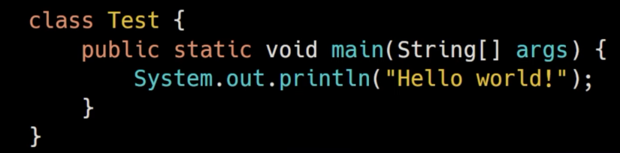

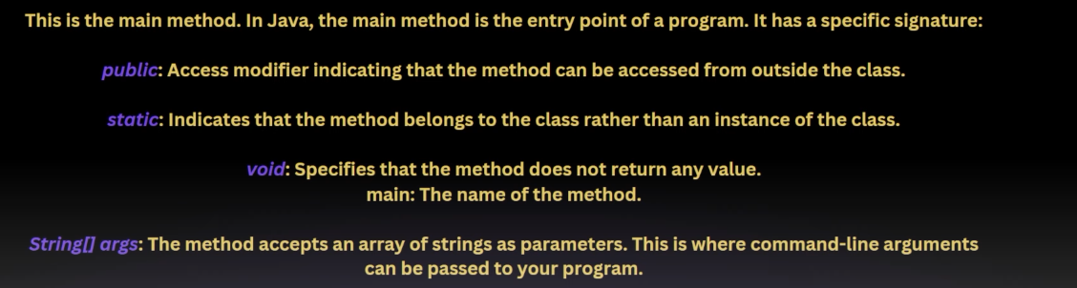

Main method is public and static so that JVM can access this method using CLASSNAME and start executing our program.

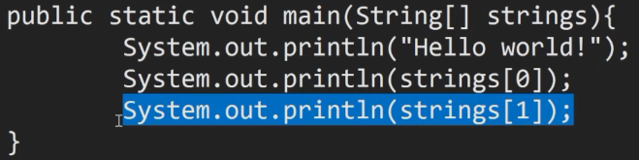

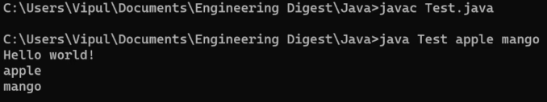

**Note –** right shift (>>) it fills leftmost bits with 1s for negative integers.

unsigned right shift (>>>) it fills leftmost bits with 0s

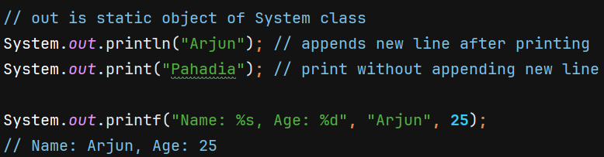

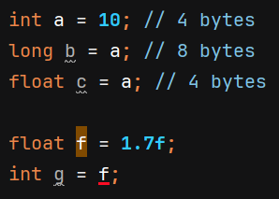 Java does not automatically convert because there is loss of decimal part, we need to do explicity type casting.

**Strings**

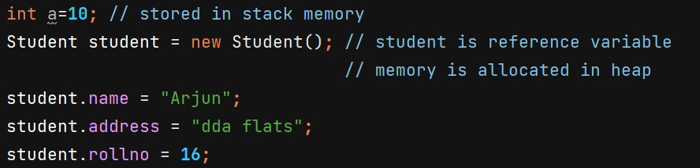

When we first time use any string literal, then JVM puts that in string pool which is portion in heap memory. And whenever we use that string literal again, it will point to the same memory location in string pool.

Reference variables are stored in stack memory which points to memory location in heap memory.

Fields of an object (primitive or reference) are stored inside that object on the heap.

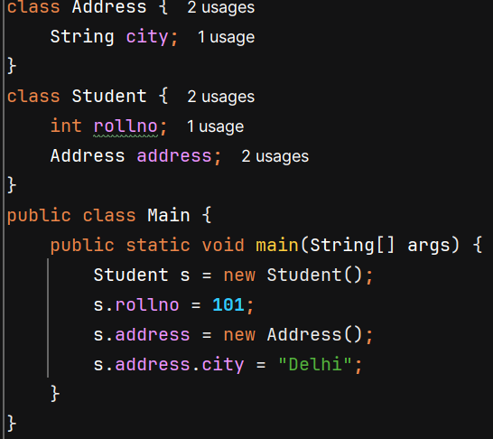 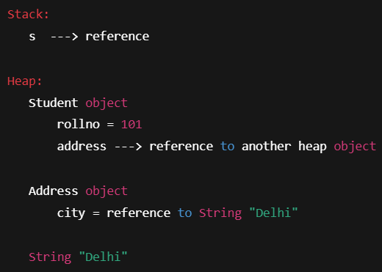

**🡺 For Primitives (like int, char, boolean)** == compares **actual values**.

**🡺 For Objects (like String, Integer, custom classes)** == compares **memory addresses** (i.e., whether both variables point to the **same object** in memory).

equals() method of String class compares by content.

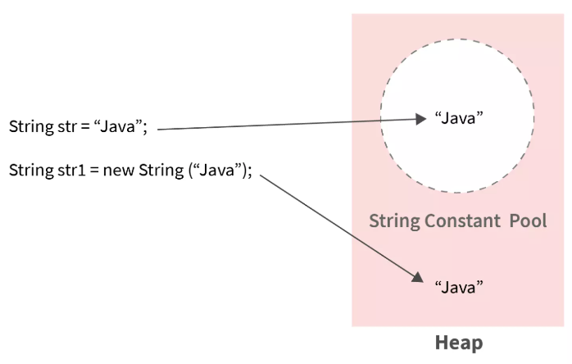 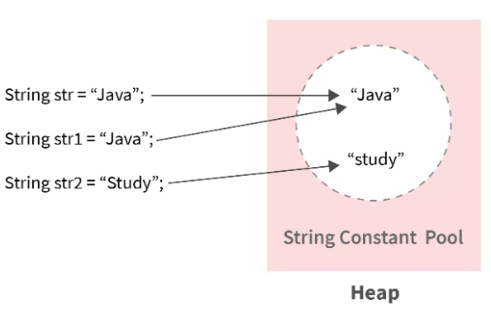

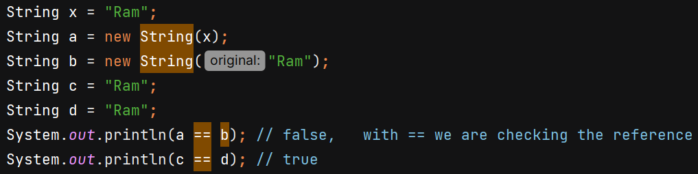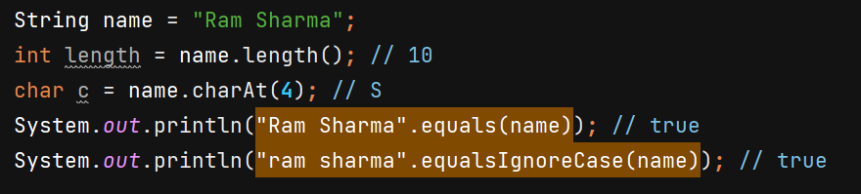

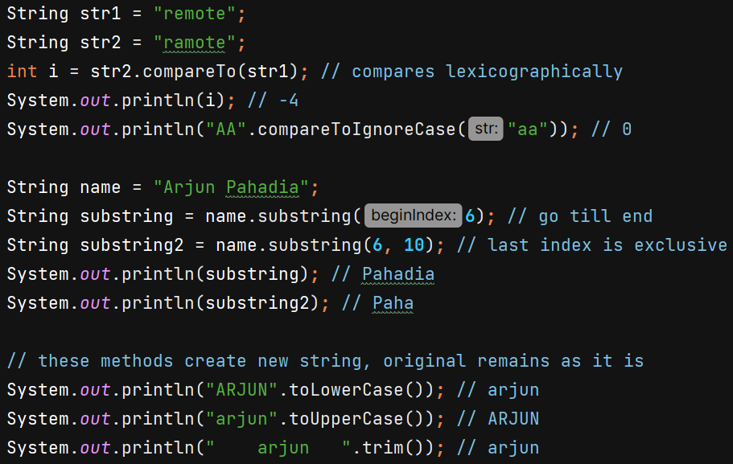

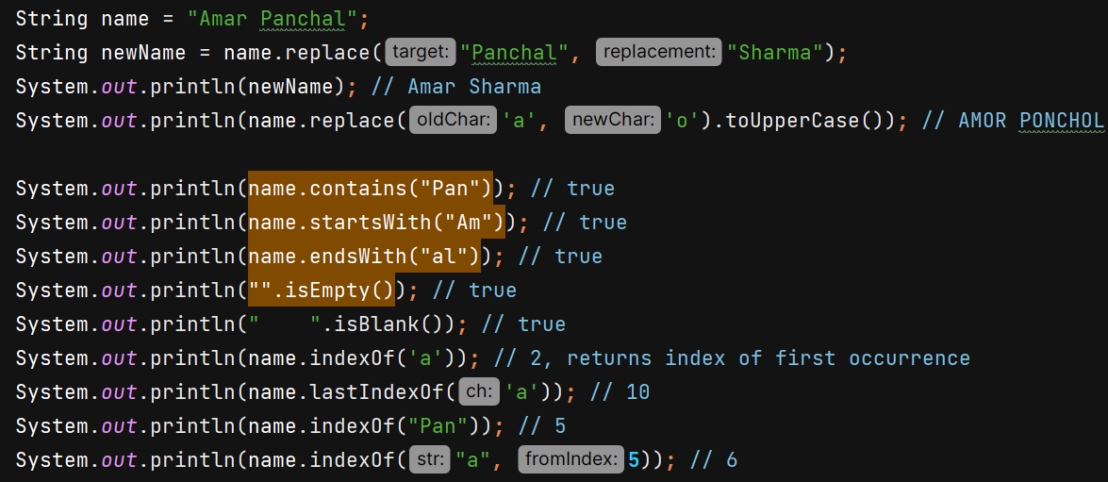

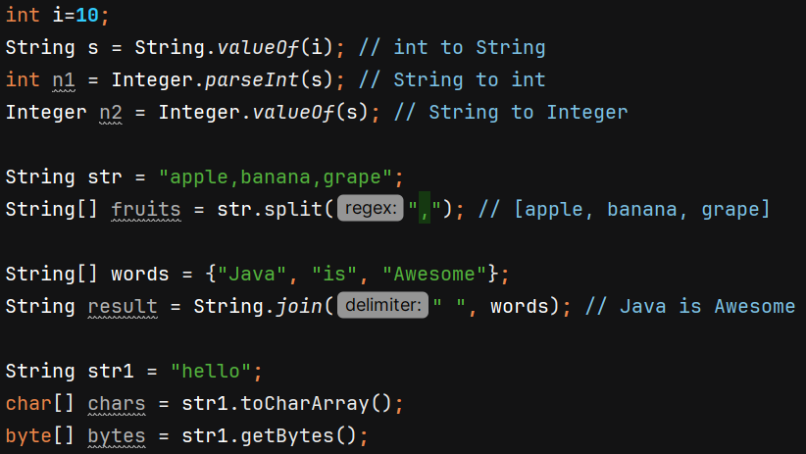

**Note :-**

* **String is immutable**, meaning once created, its value cannot be changed. Any modification results in the creation of a new String object. **It is thread-safe**.
* **StringBuilder is mutable,** meaning you can modify its content without creating a new object. It is not thread-safe.
* **StringBuffer is mutable**, allowing modifications without creating a new object.

It is thread-safe, meaning all methods are synchronized, making it slower but safe to use in multi-threaded environments.

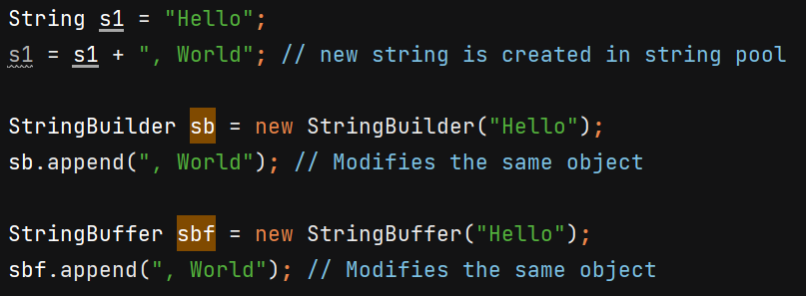

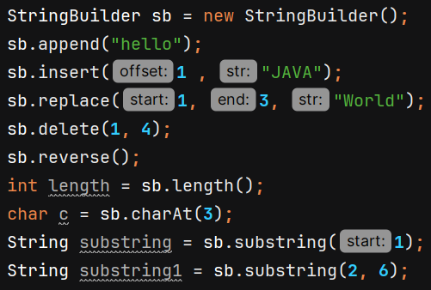

Internally, StringBuilder uses character array of 16 size which doubles its size when it becomes full and all characters are copied.

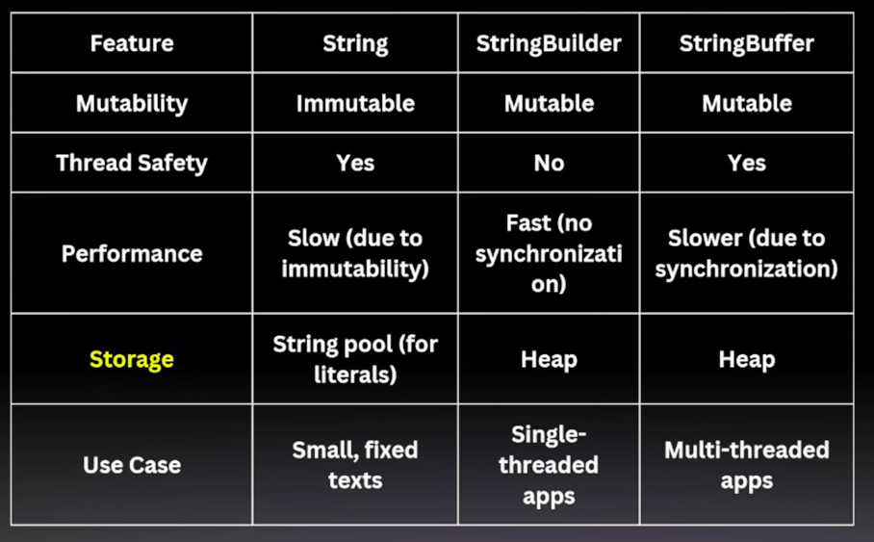

Reverse a String – 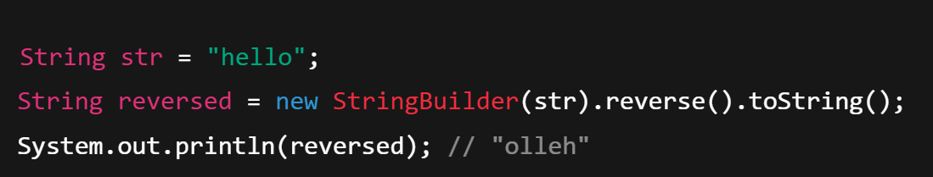

Changing any particular index character – 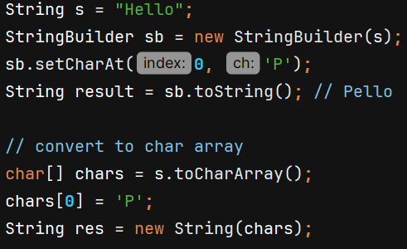

**Arrays** – In Java, all arrays are objects, regardless of whether they hold objects (like String[], Student[]) or primitive data types (like int[]).

* Array object is stored on heap memory
* Reference variable ‘arr’ is stored on stack memory with stores reference to array object

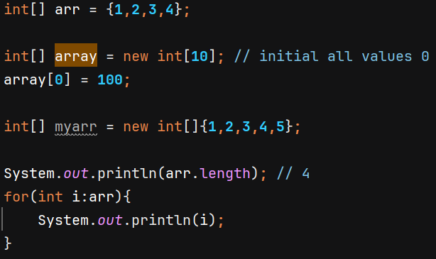 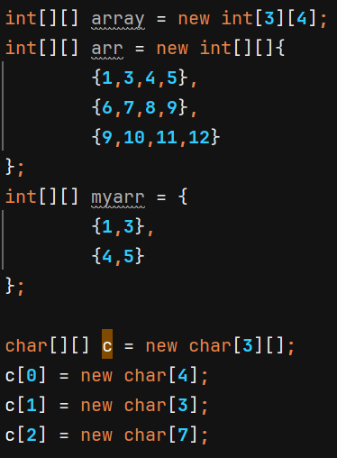

Array of objects – 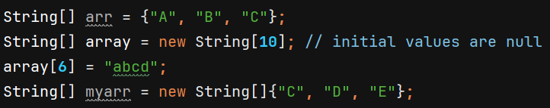

**Passing variable arguments –**

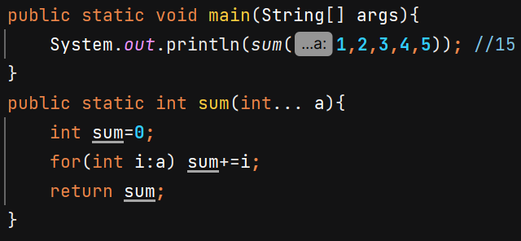 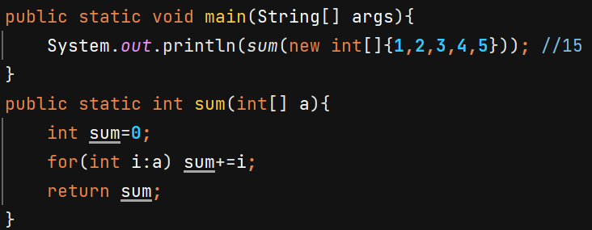

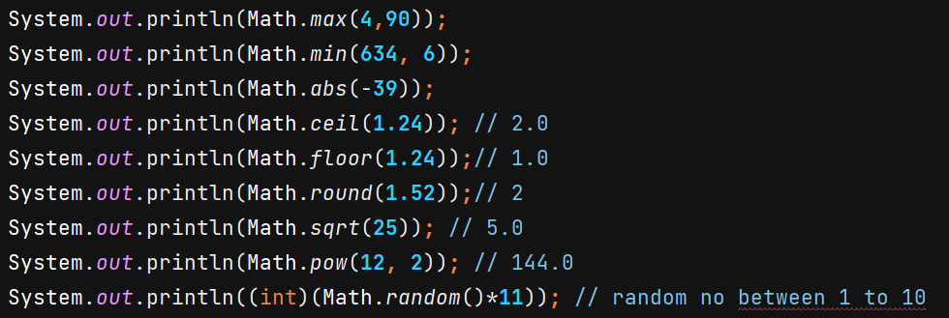 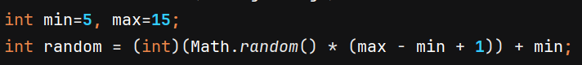

Note :- In a **switch case statement** in Java, if you do not use the **break statement** at the end of a case, the program will continue executing the body of all subsequent cases until it encounters a break statement or reaches the end of the switch block.

**Access Modifier** – keywords which describe the visibility of class, method and instance variables.

**1) Public :** can be accessed through any class in any package

**2) Private :** can be accessed by methods only in the same class

**3) Protected :** can be accessed by other classes in same package or other sub classes in different package

**4) Default :** It can only be accessed by classes in same package. If we do not mention anything , then Default access specifier is used by Java.

On Classes we can only have public or default access modifier. Only nested classes can be private.

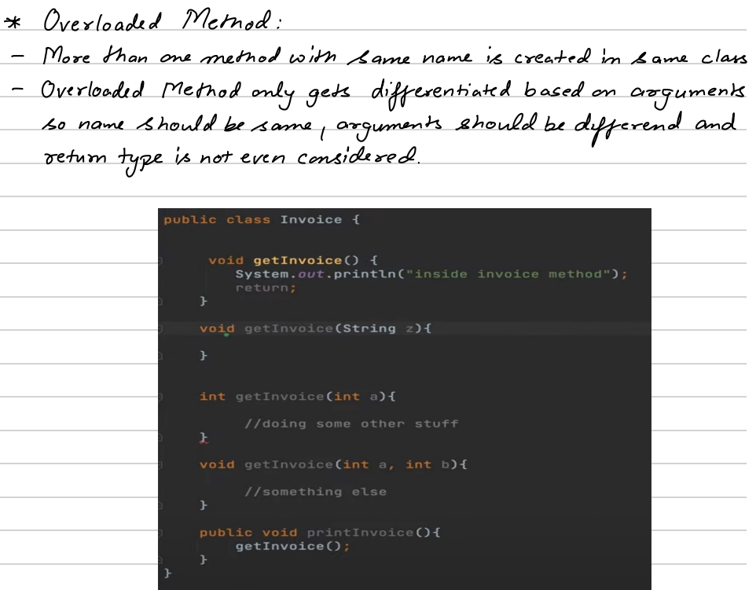

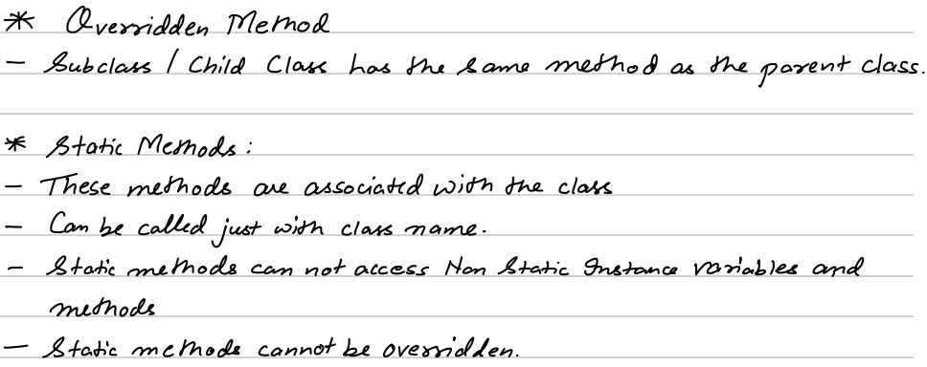

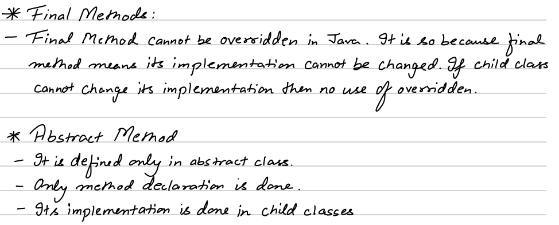

**Constructor**

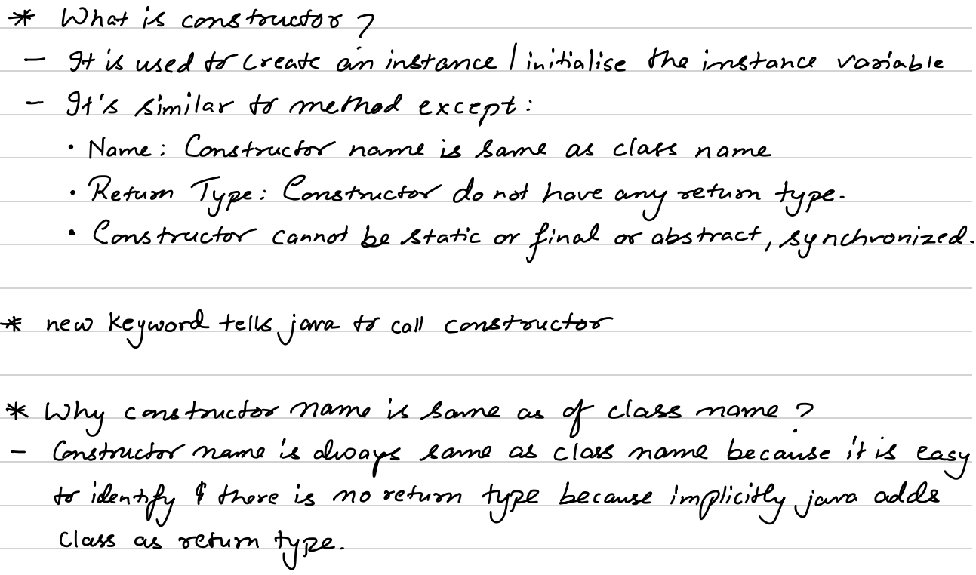

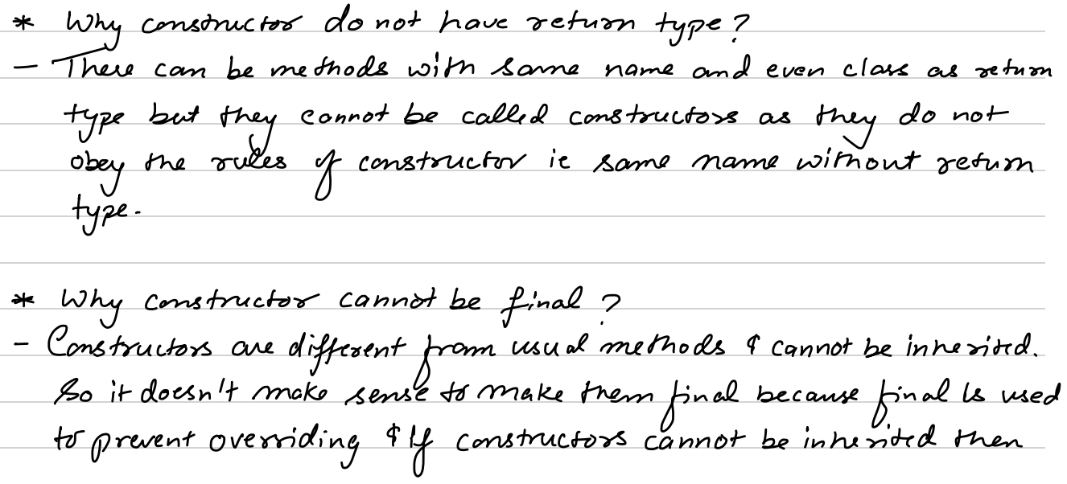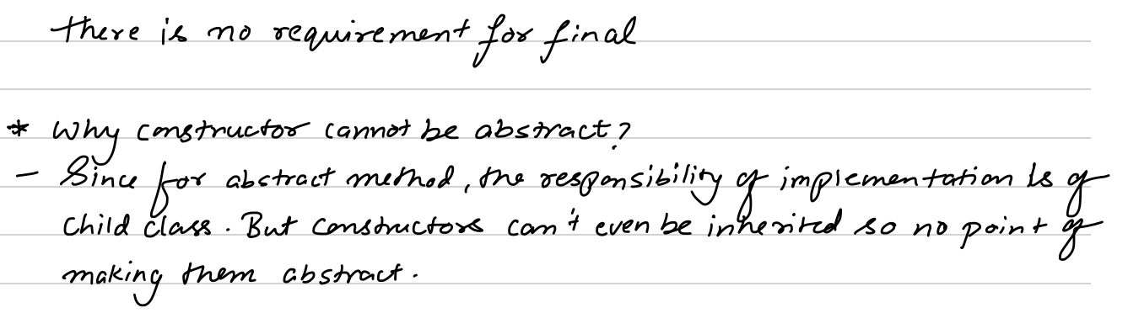

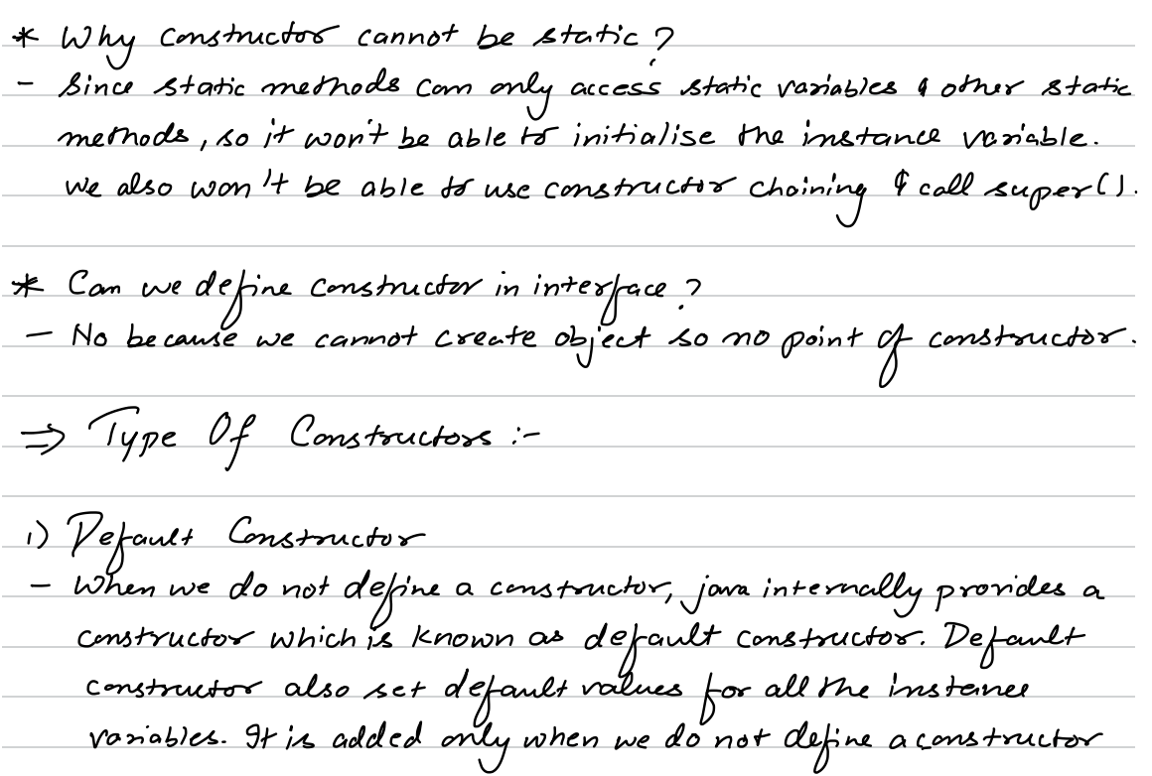

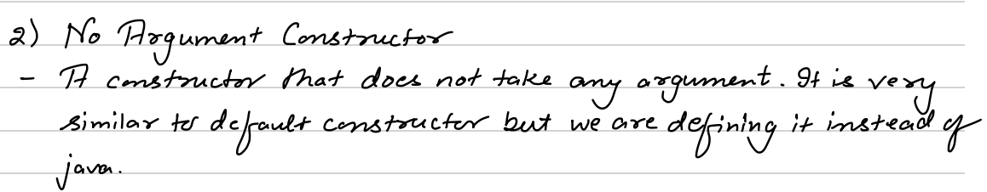

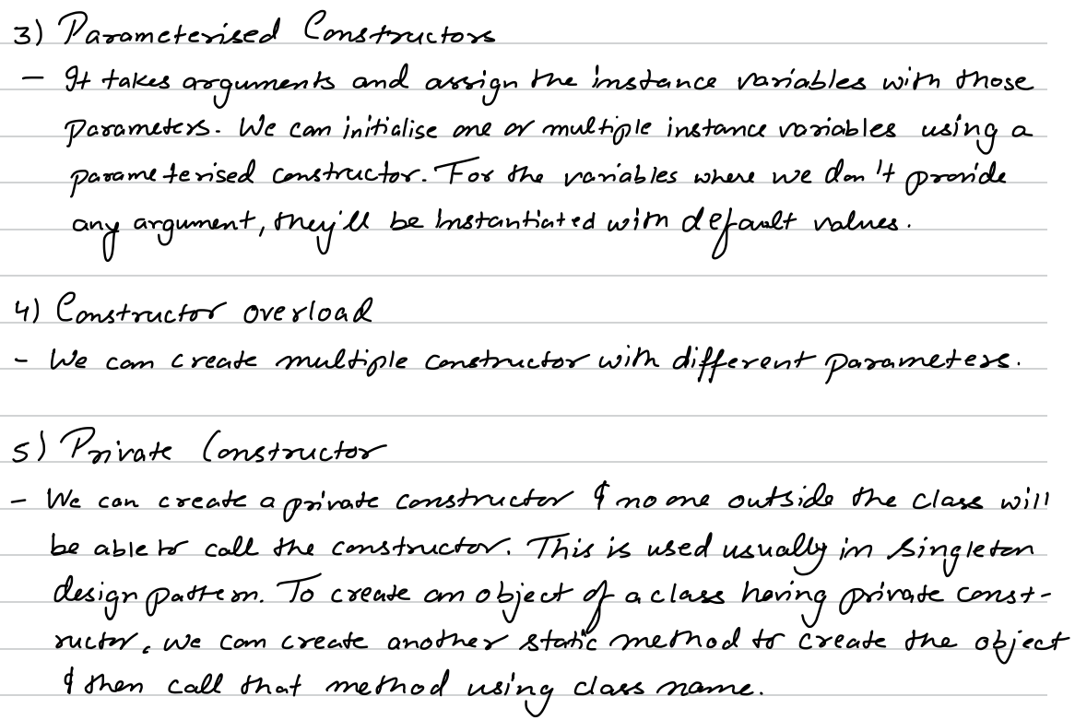

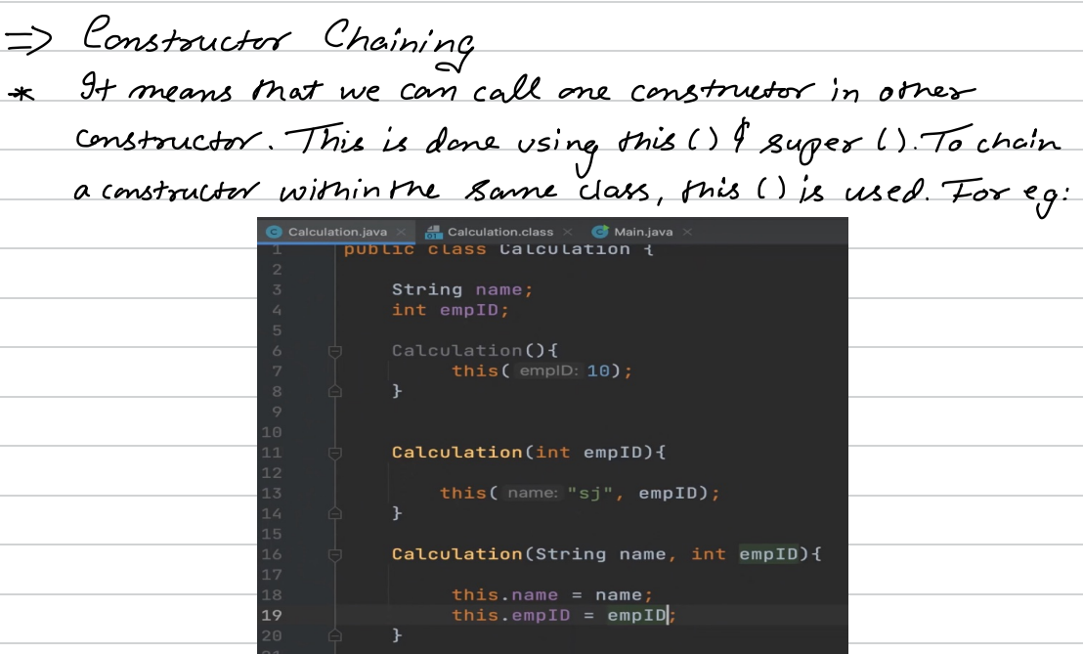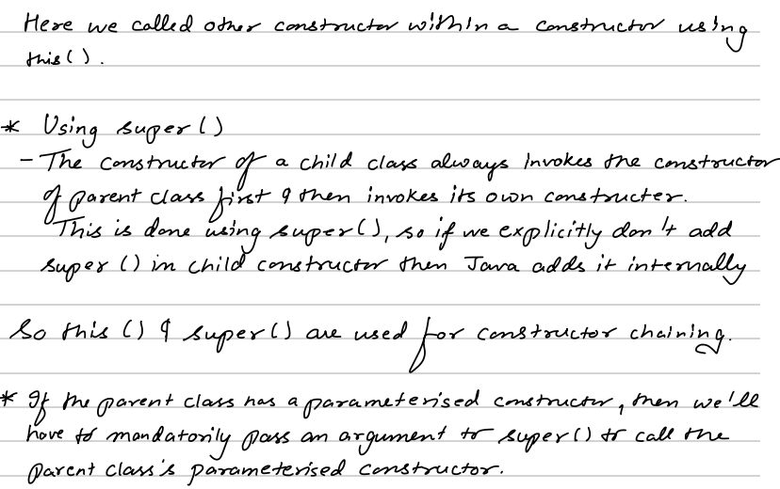

**OOPS**

It is a programming paradigm in which we deal with classes and objects.

**Class** is a blueprint for objects. Ex – Car has properties like brand, model, color, max speed and has behaviours like accelerate, brake, etc. These properties and behaviours are defined in a blueprint.

**Object** is a particular instance of a Class. We can create multiple car objects from Car class.

4 Pillars – Encapsulation, Inheritance, Polymorphism and Abstraction

**Encapsulation** – Clubing of data and methods into a single unit called class. It focuses on restricting access to data and methods using access modifiers. We achieves it by:

1. Making fields (variables) private
2. Providing public getter and setter methods to access and modify the private fields.

**Inheritance** – It allows child class to inherit some properties and behaviours from parent class. It helps in code reusability.

Ex - 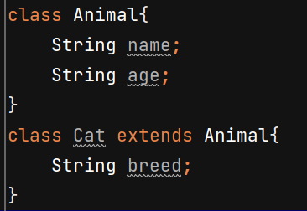

Types of Inheritance:

* Single Inheritance - a **child class** inherits from only one **parent class**.
* Multilevel inheritance – class A inherits from class B and class B inherits from class C, forming a chain.
* Hierarchical inheritance - **multiple child classes inherit from a single parent class**.
* Multiple Inheritance – Java does not support it to avoid diamond problem. However, Java supports multiple inheritance through interfaces.

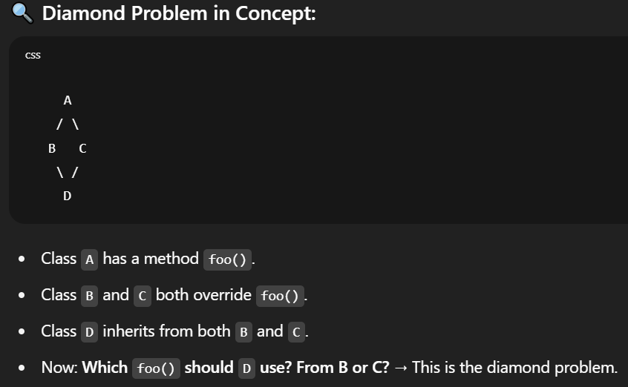

Order of constructor called –

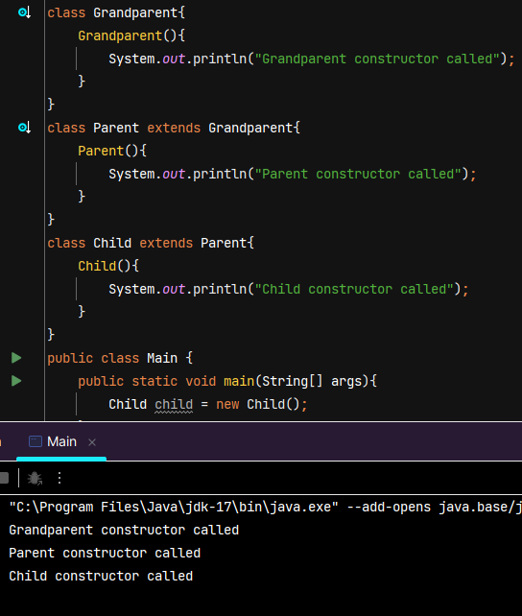

If you define a parameterized constructor, the default (no-argument) constructor is not automatically provided by the compiler. Default constructor gets the same access level as the class.  
  
Private methods of parent class are not inherited so they can’t be overridden.

**Note – this keyword is a reference to the current object — the object on which the current method or constructor is being invoked.**

**Super keyword refers the immediate parent of child class**

When a child class constructor is invoked, the compiler **automatically inserts a call to the parent class's no-argument constructor (super())** at the very beginning of the child constructor. We can also do this explicity but it should be done at beginning.

If the parent class does **not** have a no-argument constructor and instead has a parameterized constructor, the compiler **cannot insert super() automatically**. In such cases, you **must explicitly call the appropriate parent class constructor** using super(arguments) and pass the required arguments.

The parent class data must be initialized before the child class data is initialized.

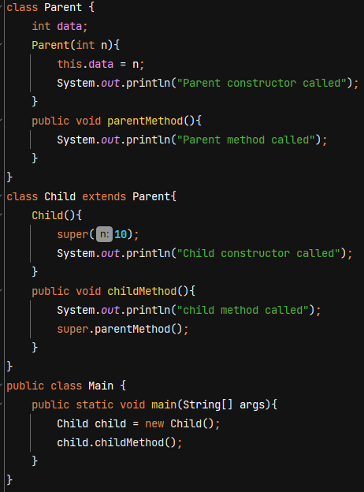 ‘this’ in Parent constructor refers to the child class object as the control flow reached there after we created child class object. No object of parent was created.

O/P 🡪 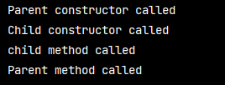

**Polymorphism** – literally means "many forms”. In programming, it means the ability of code to behave differently in different context.

**Types –**

**1. Compile time –** for a set of code we’ll decide at compile time what operation to perform and its behaviour. It can be achieved by method overloading (decide at compile time which method to call based on the parameter)

Method overloading – same name but different parameter list

Ex- 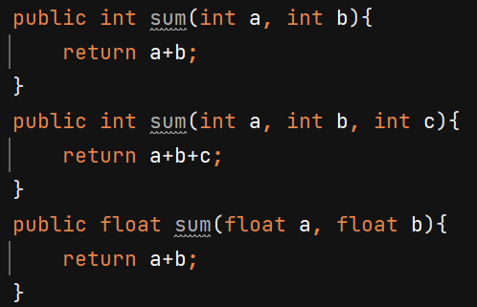

Note: we differentiate methods based on signature (name + parameter list) not return type.

Error - 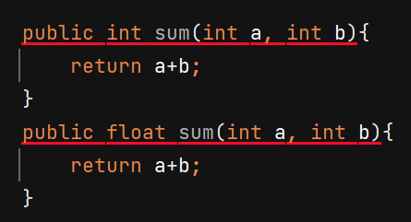

**2. Runtime –** we decide at runtime what operation to perform and the beaviour of code. It can be achieved by method overriding.

Ex – Dog & Cat class overrides the makeSound() method of parent class Animal.

Reference variable of parent class can hold the memory address of child class object.

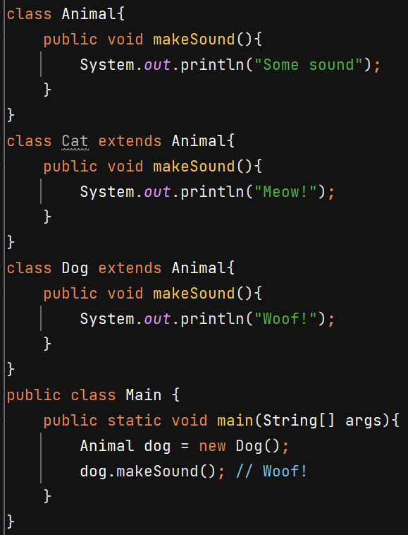

JVM will decide on runtime whose makeSound() method to call.

It is also called dynamic method dispatch or Upcasting.

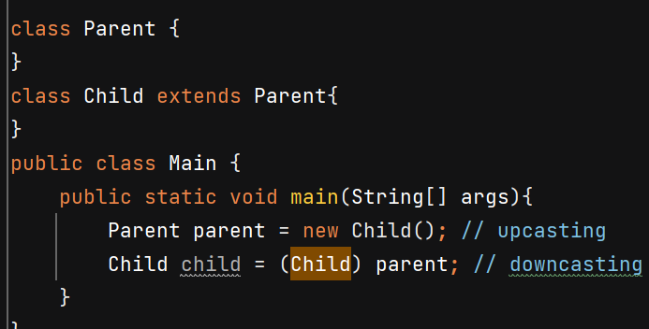

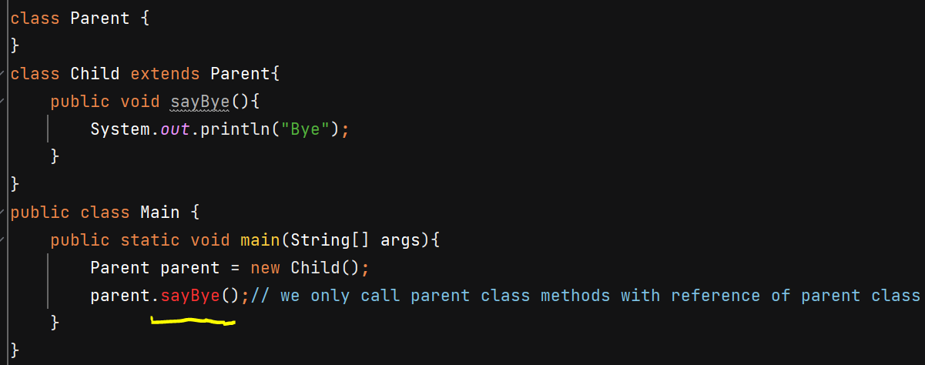

**Abstraction** – hiding implementation details from end user. Ex- we press the TV remove button to increase/decrease volume but we don’t care how remote works internally. We just care about the fact that on pressing the volume should increase/decrease.

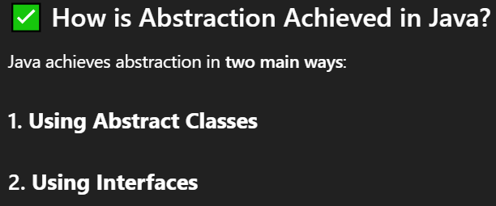

**Abstract Classes**

* Declared using abstract keyword
* Can have both **abstract methods** (no body) and **concrete methods** (with body)
* We cannot make object of abstract class. A class which extends an abstract class should either override the abstract methods of parent class or make the child class also abstract.

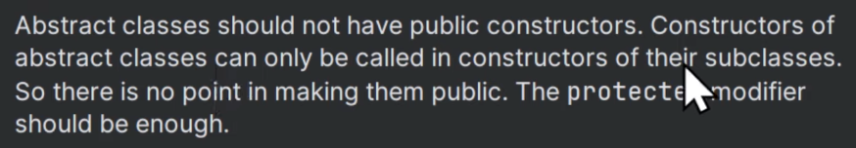

Abstract methods of an abstract class should not be private as they won’t be accessible outside class. We’ll get ERROR

If u don’t mention access modifier (package private) then its child classes in other packages cannot override it as that won’t be accessible there. So, making it protected can help. (it will be accessible within same package and inside child classes). Now child classes can override it and write its own implementation.

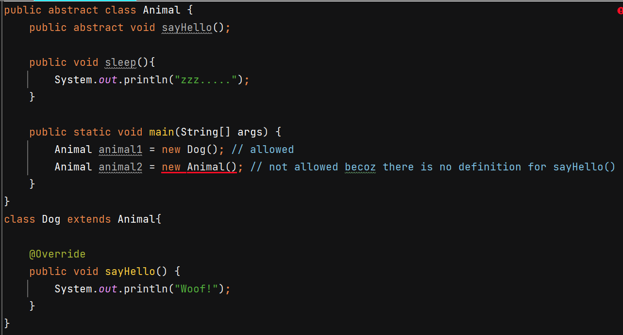

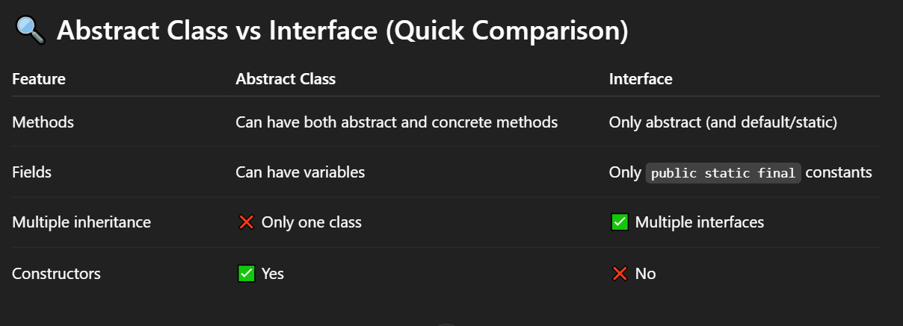

**Static Keyword**



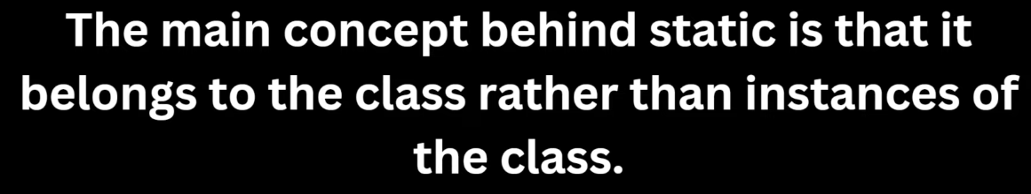

Ex – 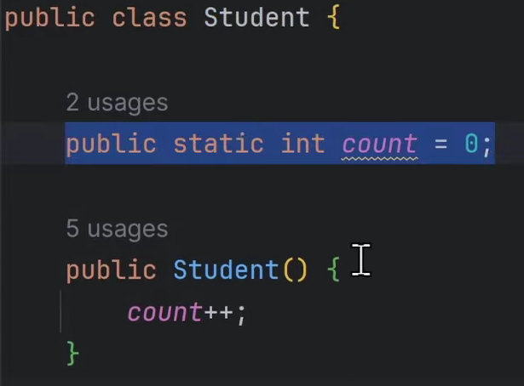 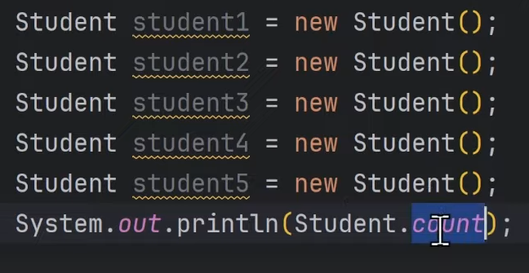

O/P 🡪 5

static method **cannot directly access non-static (instance) variables or methods**.

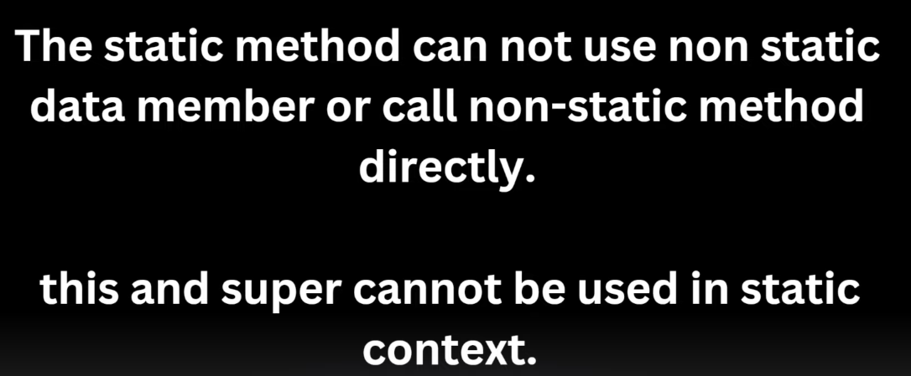

**Note** – static block is executed **once when the class is loaded into memory by the JVM** *before* any object is created or any static method is called.

Static block is used for performing static initialization, for 1 time setup task.

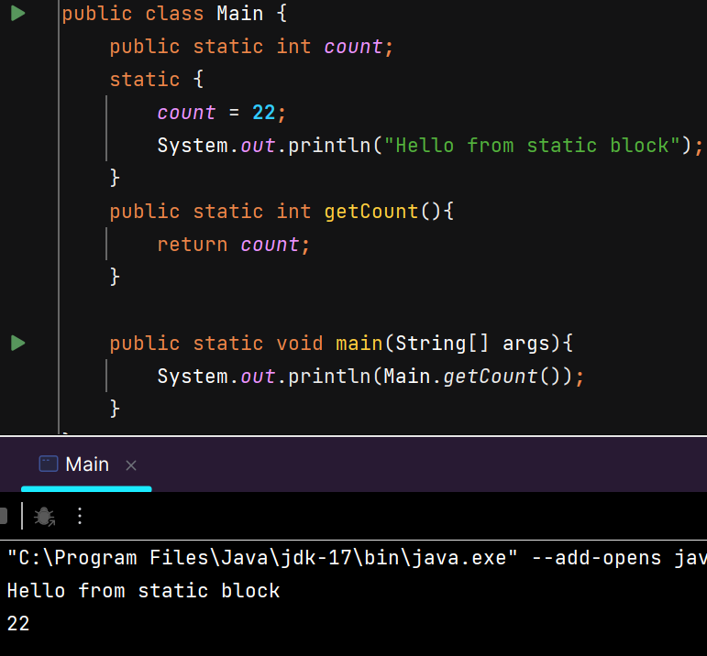

**Final Keyword**

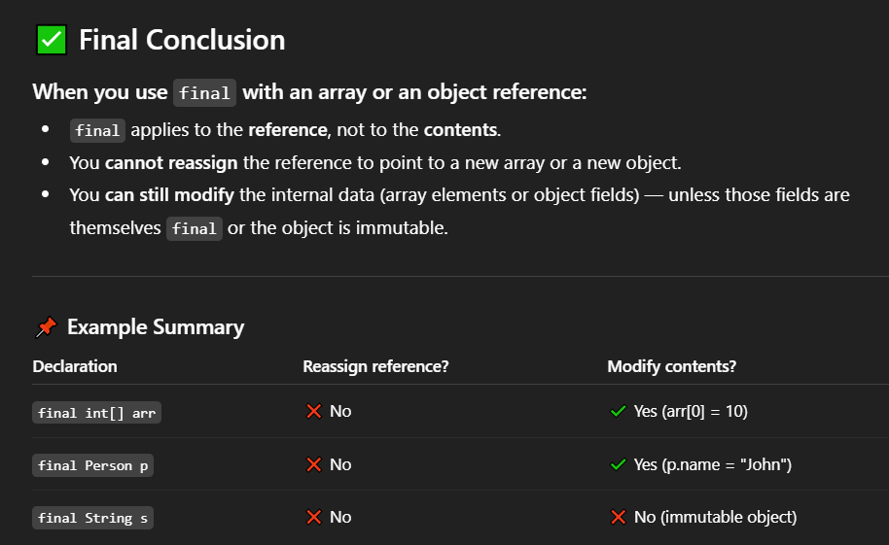

Used with class fields to make them constants.

🡺 We can only assign value to a final variable at the time of declaration or in static block or inside constructor if field is not static.

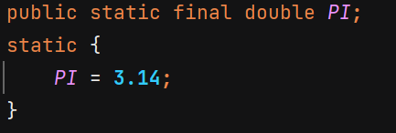 or 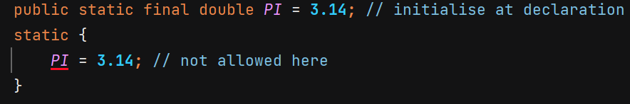 or 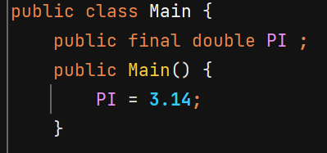

Final keyword can be used with methods if we want that no child class should be alllowed to override the method –

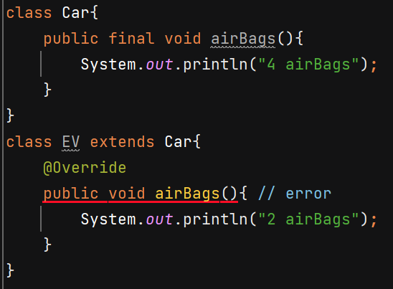

We can also make a class final if we don’t want any other class to extend our class –

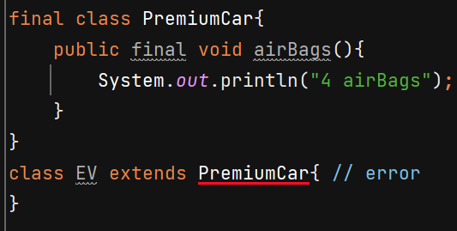

Using final on constructor makes no sense because we use final to prevent overrriding and constructor is already not inherited. There is not concept of overriding constructors.

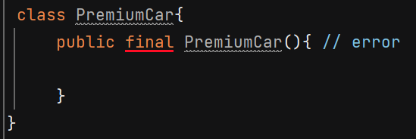

**Note** – **finalize()** is a cleanup **method present in Object class** which is called by GC before destroying an object — but it is now deprecated since java 9.

**Interface**

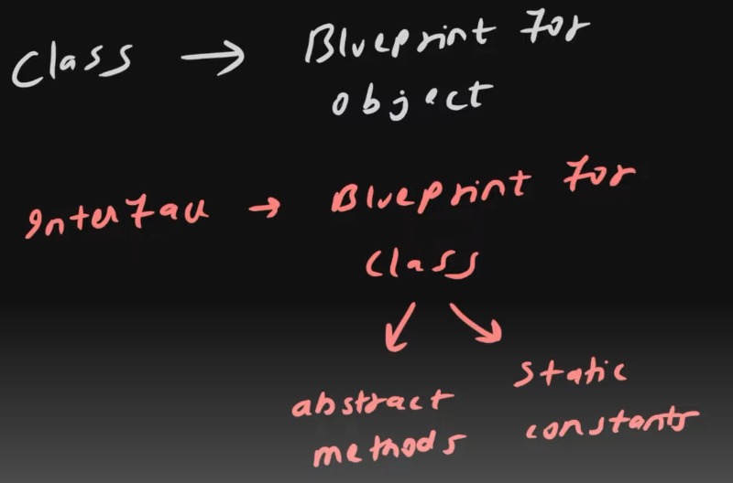 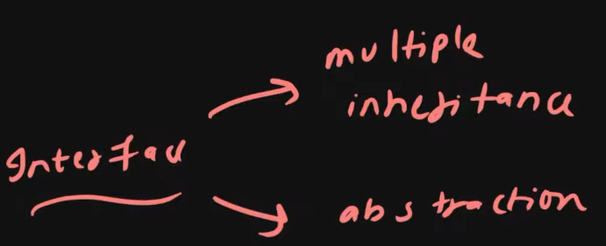

Interfaces do not have concrete methods. Classes that implement the interface must provide the implementation for all its abstract methods, ensuring full abstraction.

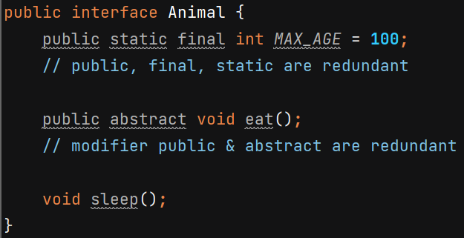

Class implementing Animal should either provide implemenation of eat() and sleep() or that class should be declared abstract –

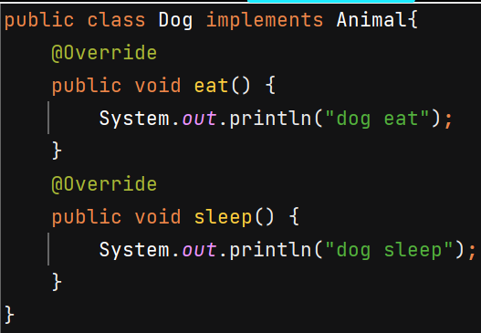 Or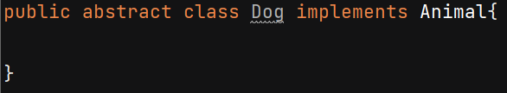

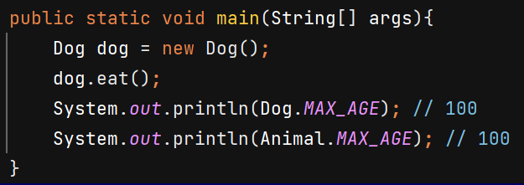

In Java version >= 8, interfaces can have static and default methods –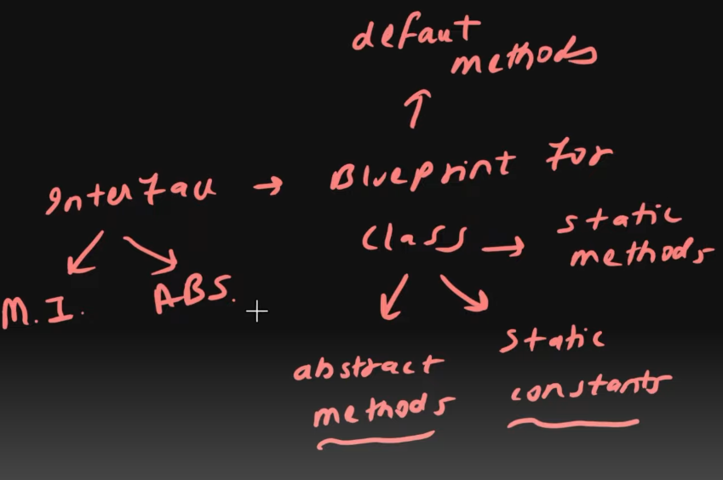

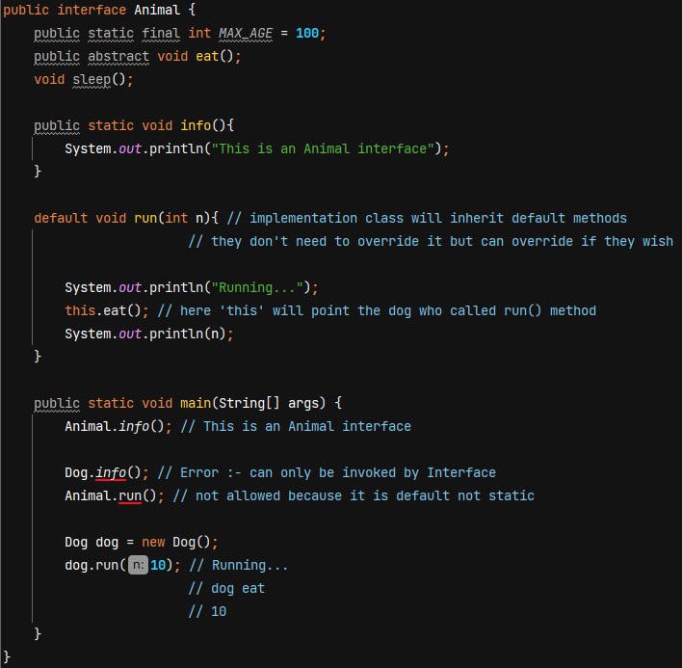

default methods *can* be called outside the class, but only through an instance of a class that implements the interface.

**Java 9 and later:**  
You *can* declare **private methods**, but **only inside the interface as helper methods** used by default or static methods.

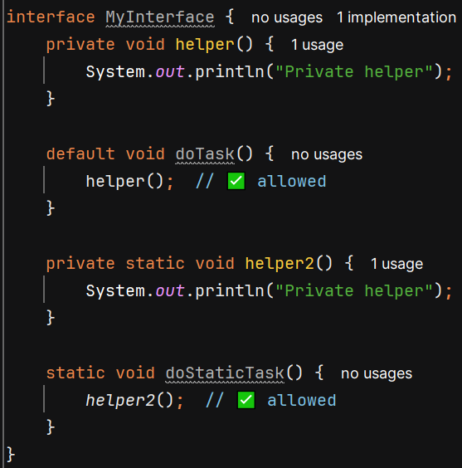

Multiple Inheritance in interfaces –

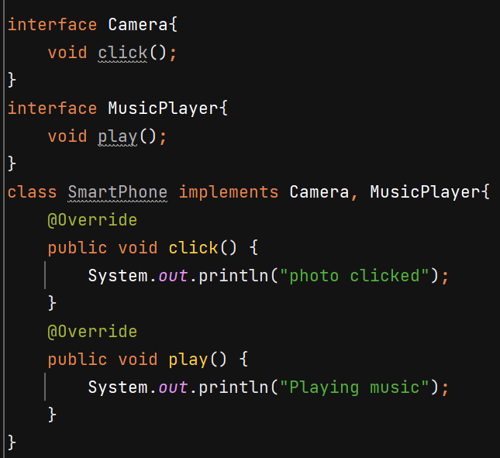

Difference between abstract class & Interfaces –

* Abstract class has instance variables and to initialize them it has constructor. But we don’t have these in interface
* 1 class only extend only 1 abstract class whereas 1 class and implement multiple interfaces.

**Inner Classes**

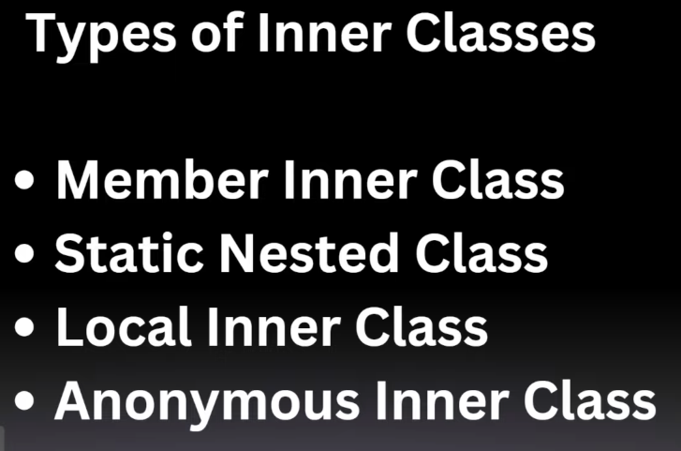

A top-level class *cannot* be private, but a nested/inner class *can* be private.

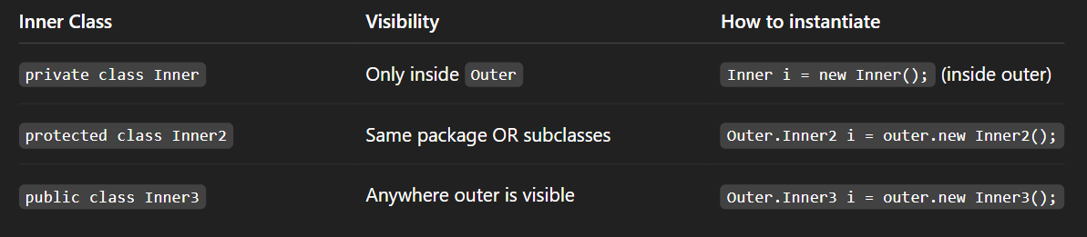

**Member Inner Class** – Inner will behave as member of outer class. It is associated with instance of outer class. Inside inner class methods we can access fields of outer class.

Engine is acting as a property for Car –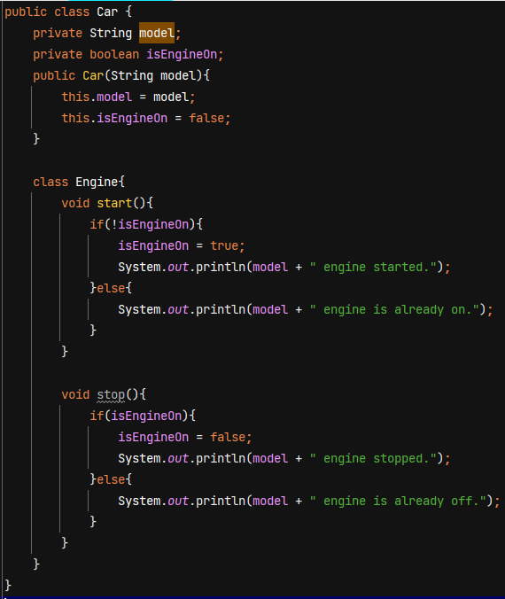

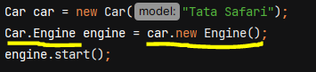

Without using it, our code increases as we need to create separate Engine class having Car as its instance variable –

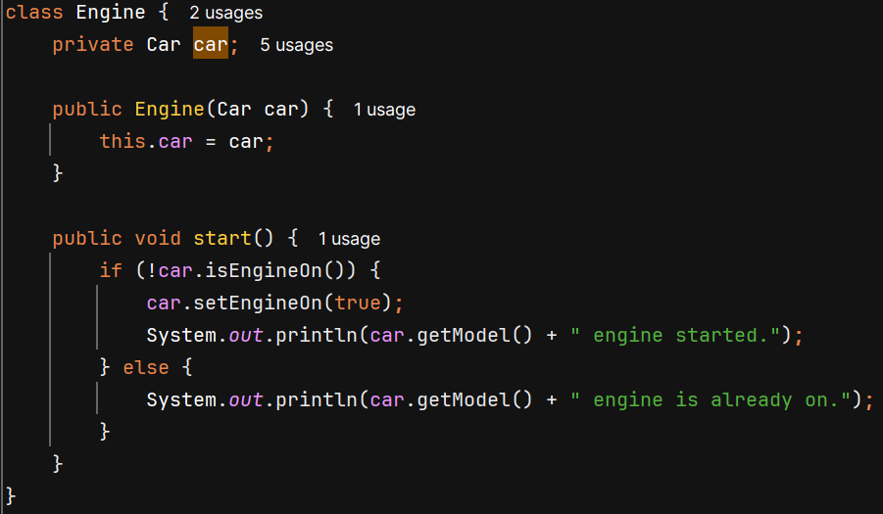 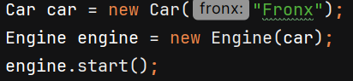

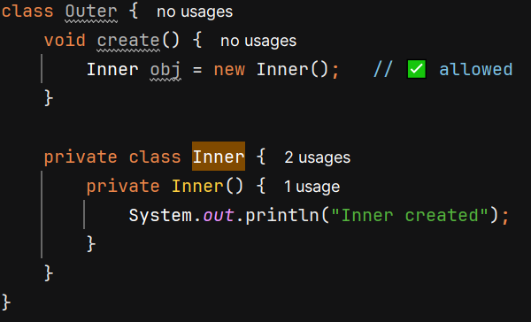 If an **inner (nested) class has a private constructor**, its object **can be created inside the enclosing (outer) class**.

Java allows the outer class to access **all private members** of its nested classes (and vice versa)

**Static Nested class** - It belongs to the outer classs rather than its instance.

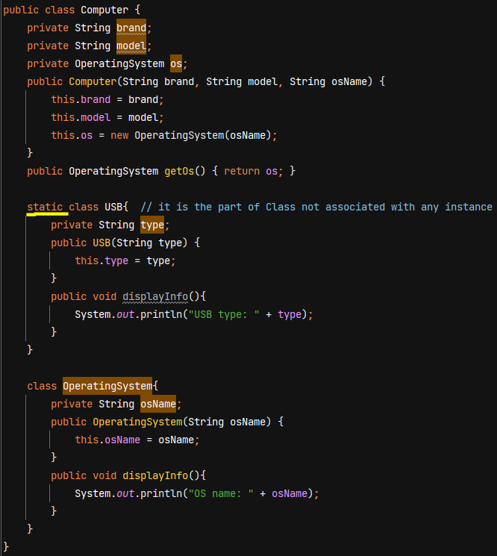

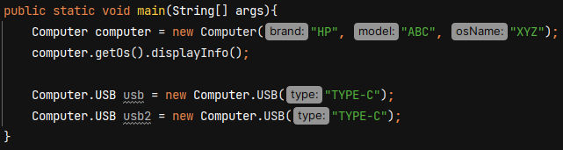

**Anonymous Inner class** – useful when we have to implement an interface without creating its separate implementation class or we have to extend a class without creating its separate child class.

Anonymous because it does not have any name.

Used for creating an object for 1 time use.

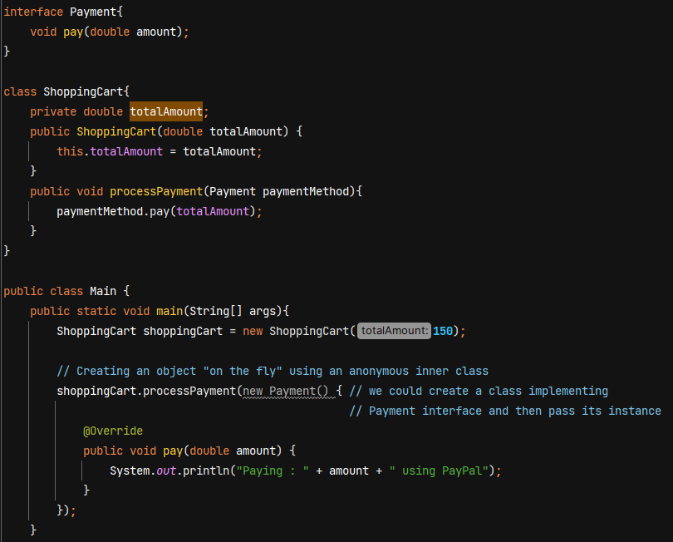

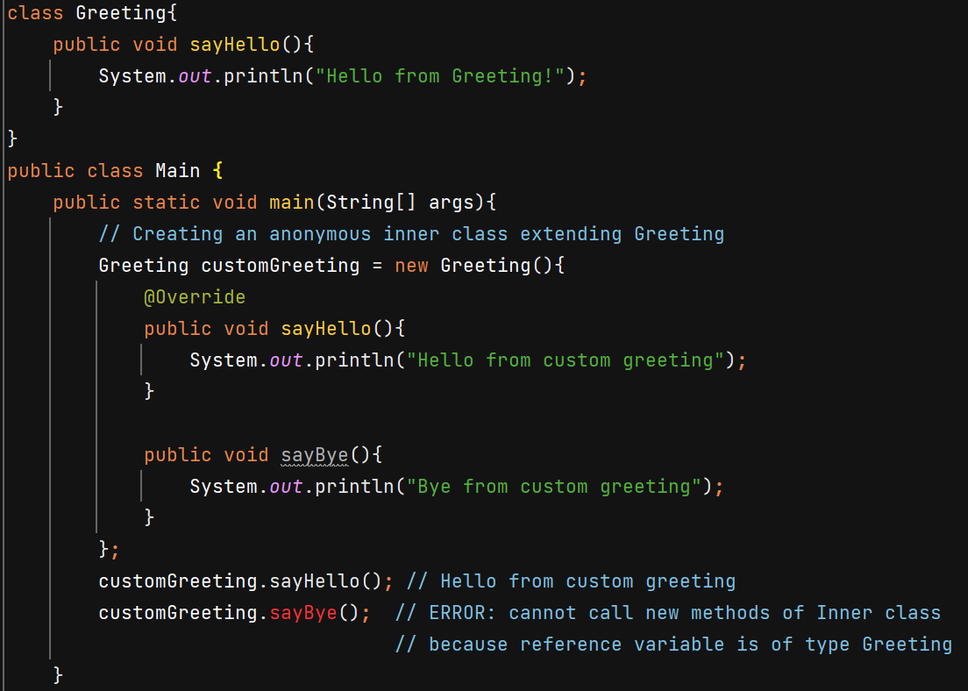

**Local Inner Class**

Used to encapsulate the logic. Ex - validation logic is tightly coupled with reservation process, so by placing the validation logic inside reserveRoom() we are setting the context that validate() function will only be used inside reserveRoom() method. So place it here only why to keep it outside.

Local Inner class can access all the instance variables of object.

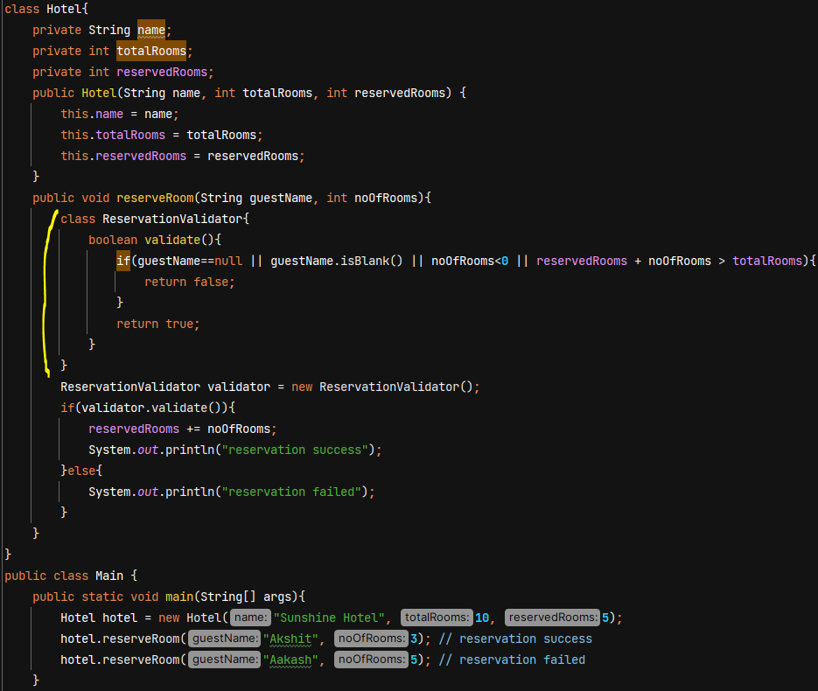

Note :- Java is not a pure object oriented language because it still has primitive data types like int, float, double, etc. Java’s **Collections** (like List, Map, Set) only work with **objects**, not primitive types (int, char, boolean, etc.).

**Wrapper Classes** – used to wrap primitive data types into objects.

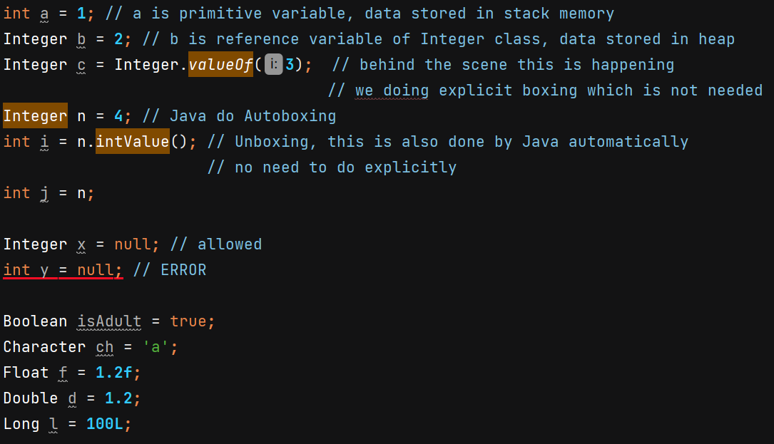

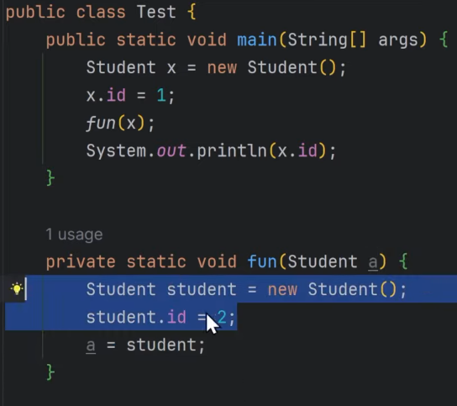 O/P 🡪 1

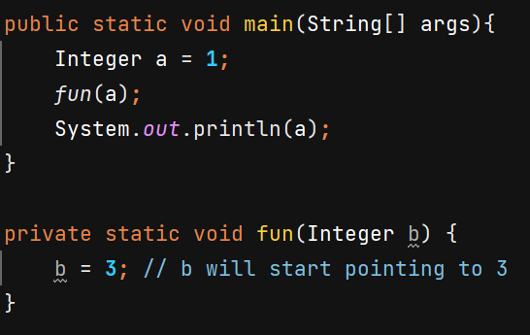 O/P 🡪 1

In Java, the wrapper classes are immutable, meaning its values cannot be changed once they are set. However, when you perform operations on them, a new instance is created to hold the result

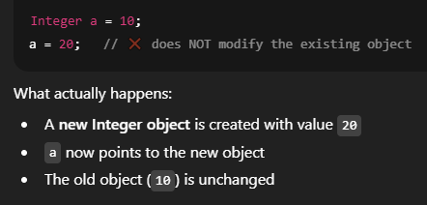

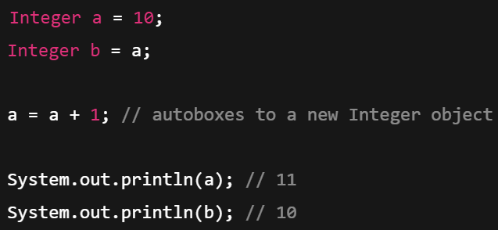

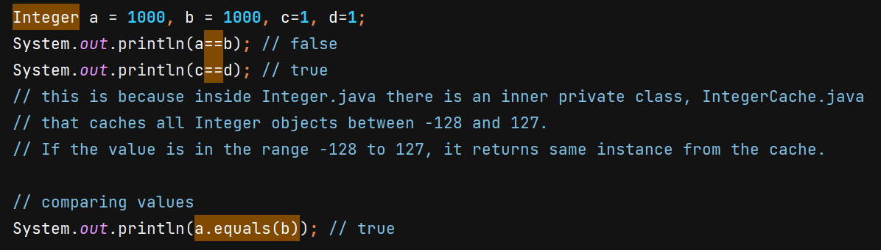

Similar caching happens in Long for -128 to 127 but don’t happen for Double and Float wrapper class.

**Enums** – used for storing fixed set of constants.

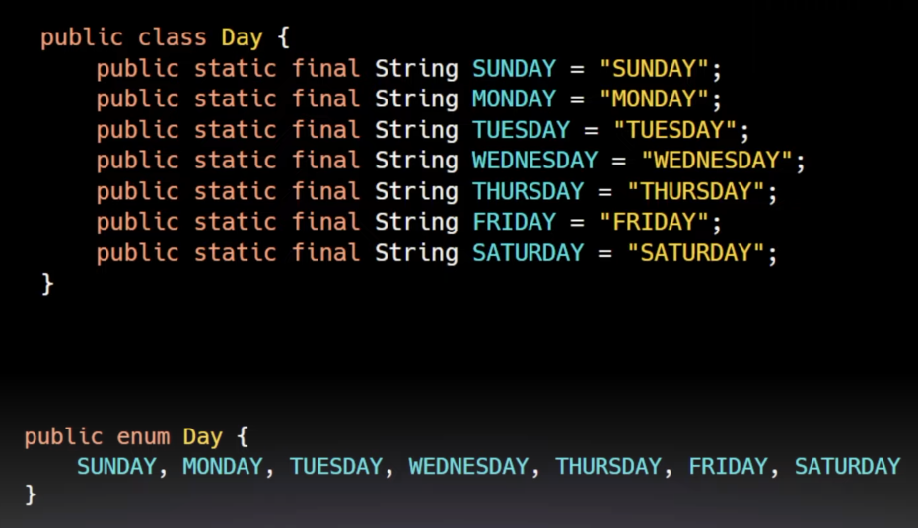

SUNDAY is a Day, MONDAY is a Day, …. They are final instances of Day class

On compile time, Day enum becomes a final class which extends java.lang.Enum<Day> class –

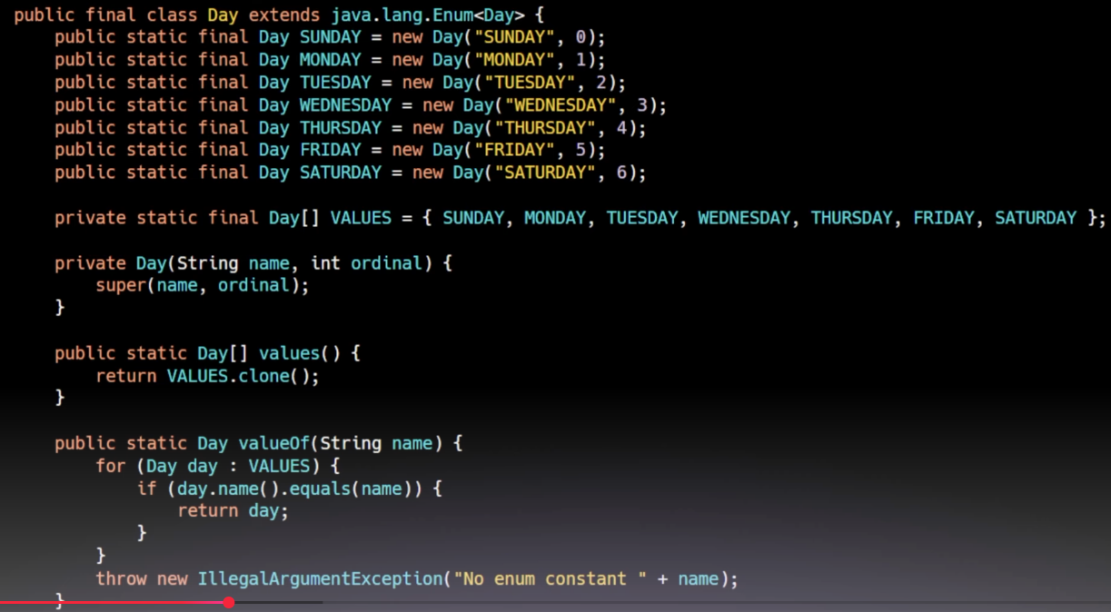

Note :- In enum, the first thing you write should be enum constants. After that we can add fields and methods.

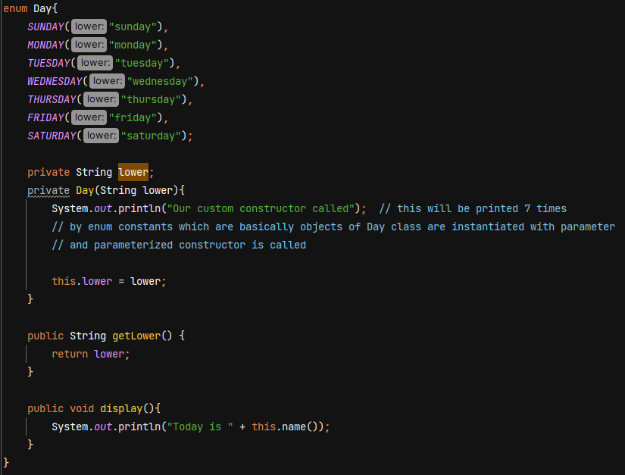

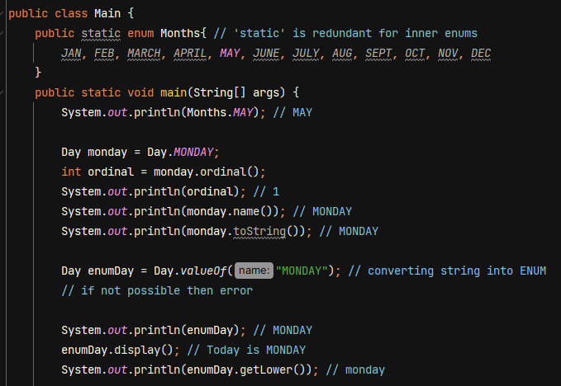

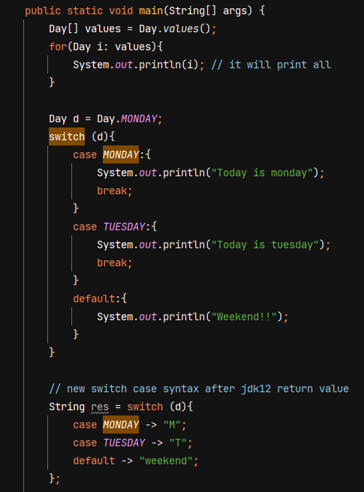

**Exception Handling**

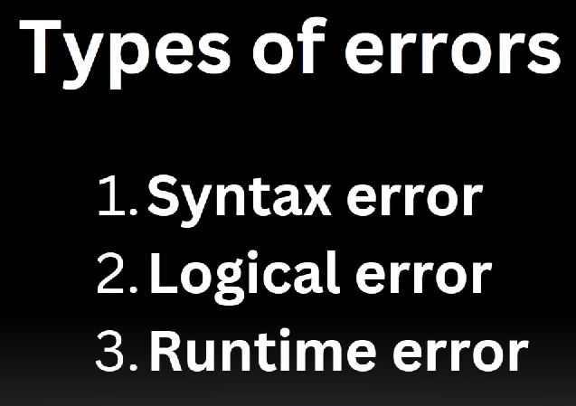

Program will crash during run time errors.



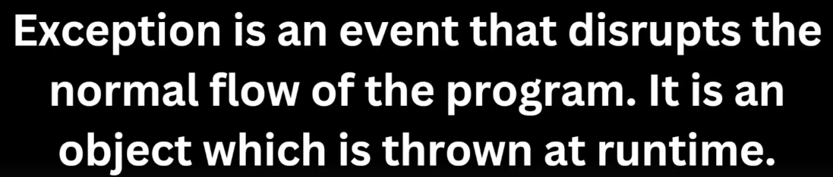

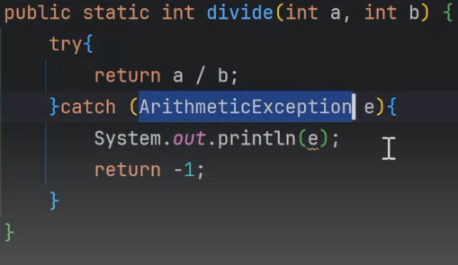 sout() uses toString() method to print object,

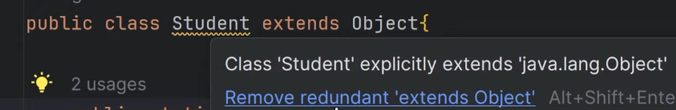 Every class extends Object class.

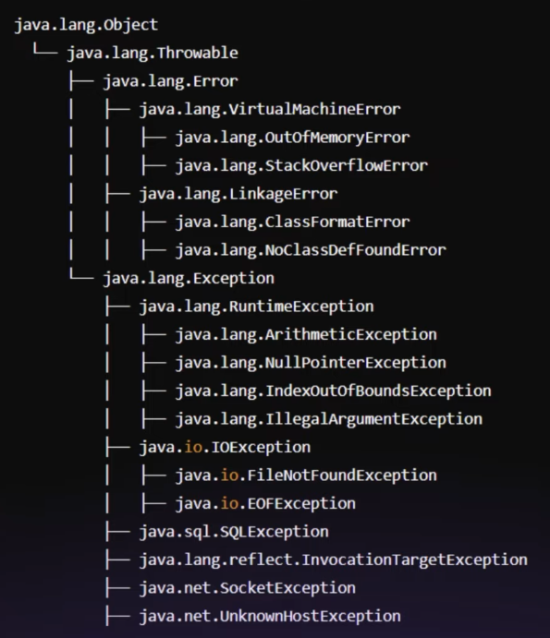

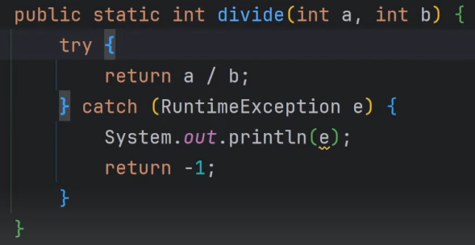 Reference variable of type RuntimeException can point to the object of ArithmeticException.

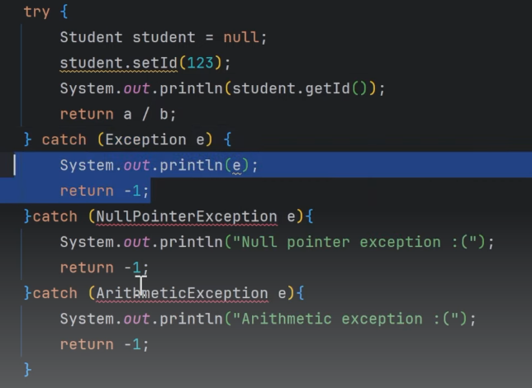 Error :- exception has already been caught

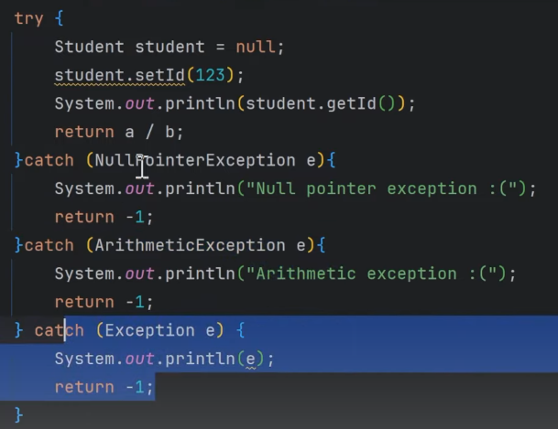

Correct way of catching exception -> first catch specific exceptions and at the last catch generic exception.

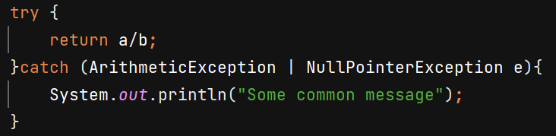 Catch multiple exceptions in single catch()

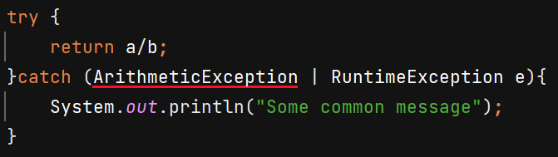 Error :- Types in multi-catch must be disjoint: 'java.lang.ArithmeticException' is a subclass of 'java.lang.RuntimeException'

**Unchecked Exceptions** – These exceptions are not being checked at compile time. Ex- ArrayIndexOutOfBound, NullPointerException, all subclasses of RuntimeException. **Do not need to be caught or declared.**

**Checked Exceptions** – which are checked at compile time. Ex- IOException, SQLException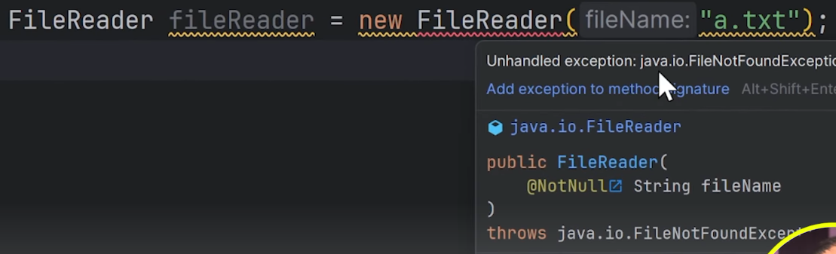

Compiler will say to handle the exception – surround with try/catch or add exception to method signature using throws.

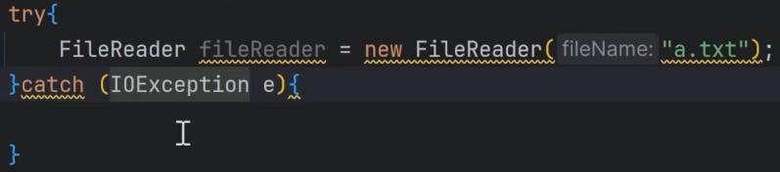

**Throws** – It is used to declare that this method can throw that exception so caller of method need to handle the exception. Caller should either use try-catch or throws the exception or else JVM will handle it by terminating the program.

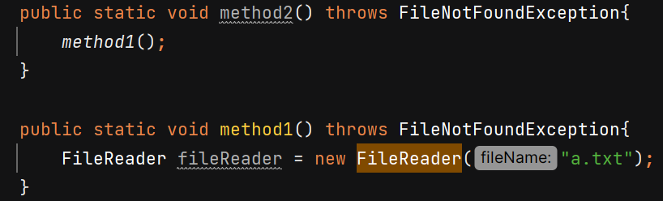

**Throw** – used to forcefully throw some exception

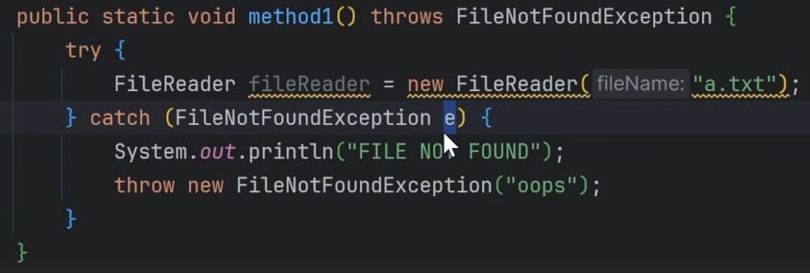

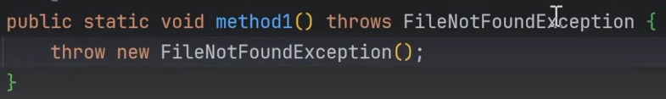 Here we have to use **throws** keyword also because FileNotFoundException is checked exception so we need to make the caller aware about it so that caller will handle it.

But if we **throw** unchecked exception then using **throws** is not necessary – 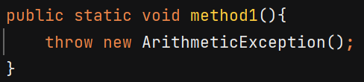

When throwing **Exception** we need to use throws because it is parent class for checked exceptions -

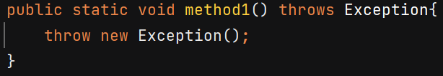

**Finally** –

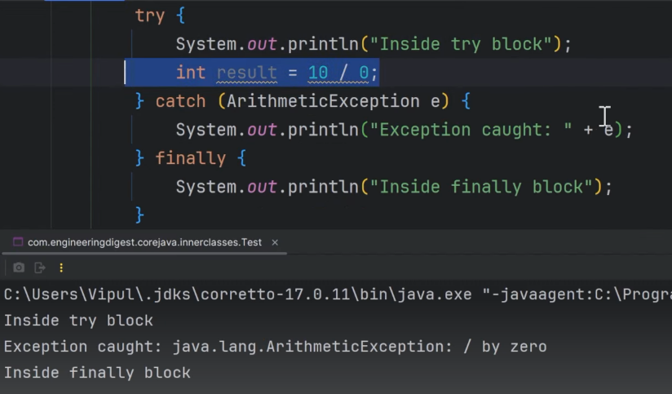

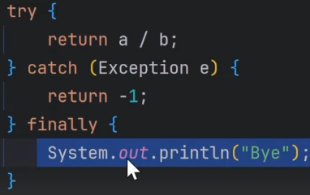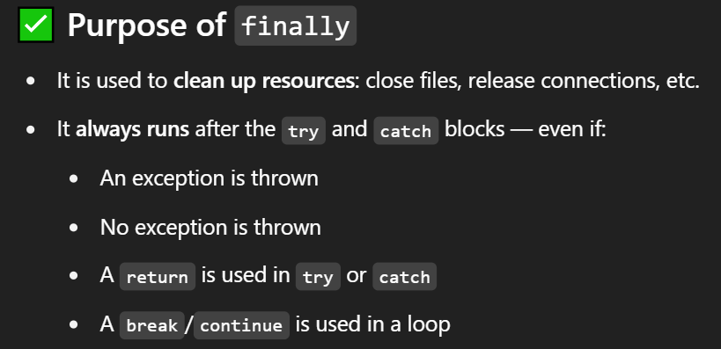

Object of BufferedReader must be closed, we can do it in finally block – 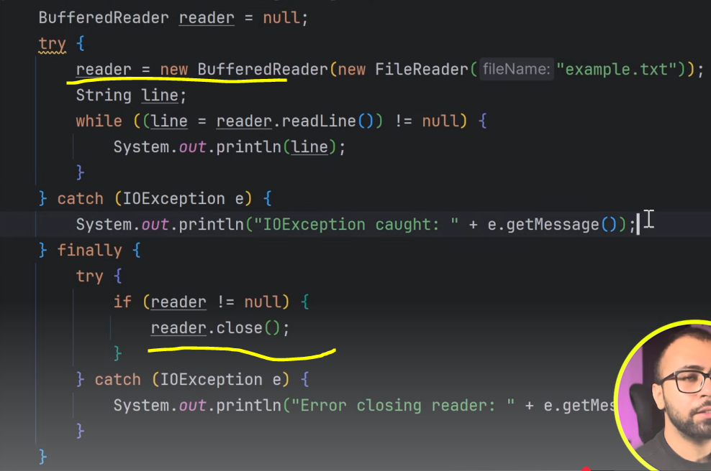



**Try-with-resource**  - no need of writing finally for closing resources

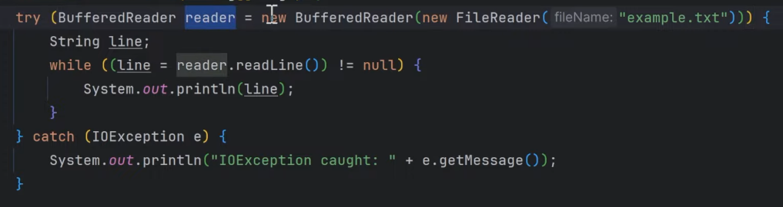

Object created within () will be closed automatically **if that object class implements AutoCloseable interface.**

close() will be automatically called.

**Custom Exception Class**  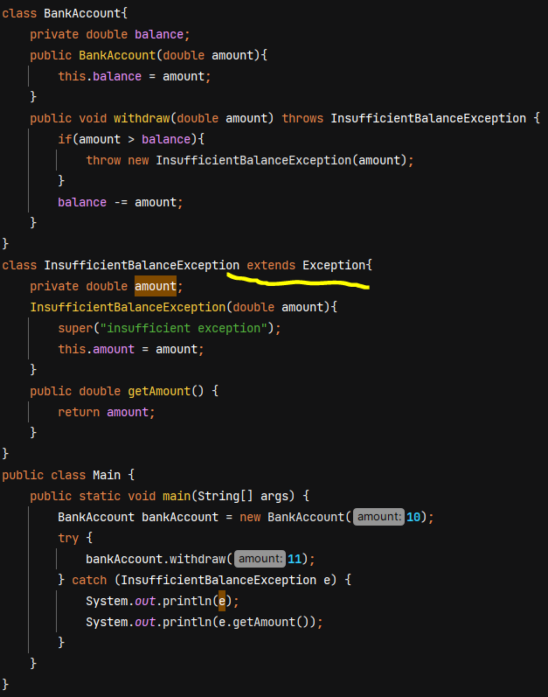

**Rules when overriding method -**

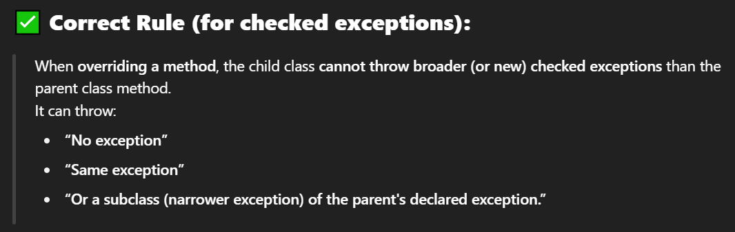

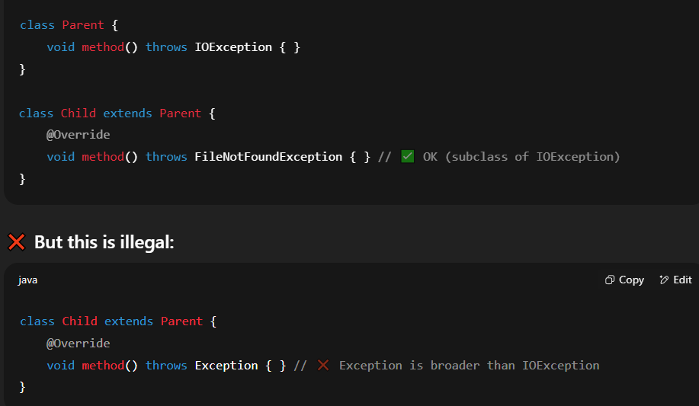

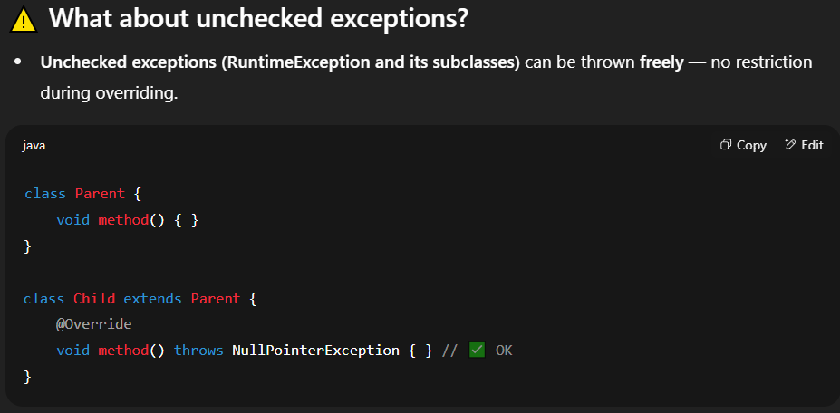

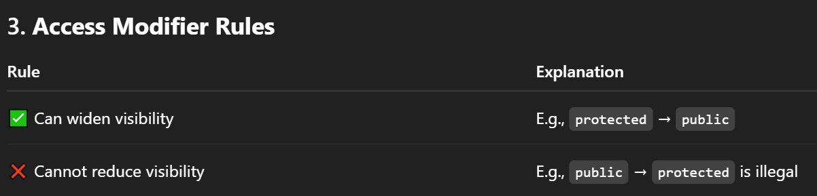

**Generics**

Ex- ArrayList stores array of Object class instances -

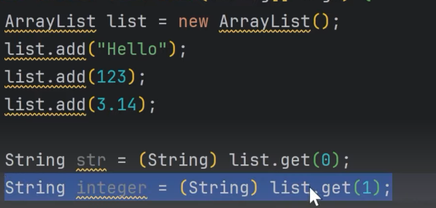 ClassCastException at runtime: Integer cannot be cast to String

Issues without generics - 

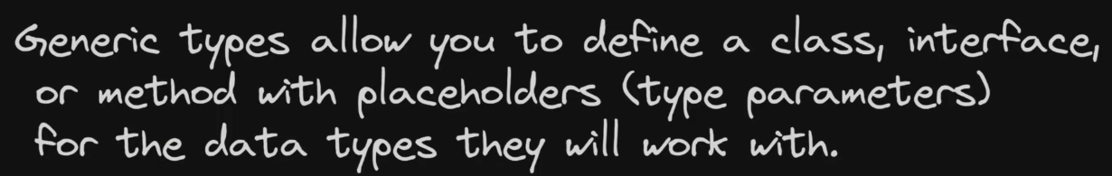

It helps avoid duplication of code and giving compile time error making it type safe –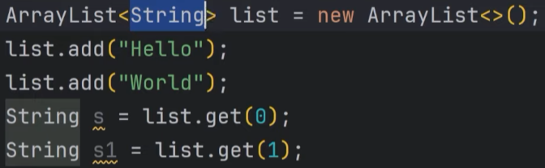 Now we can’t add Integer in String Arraylist

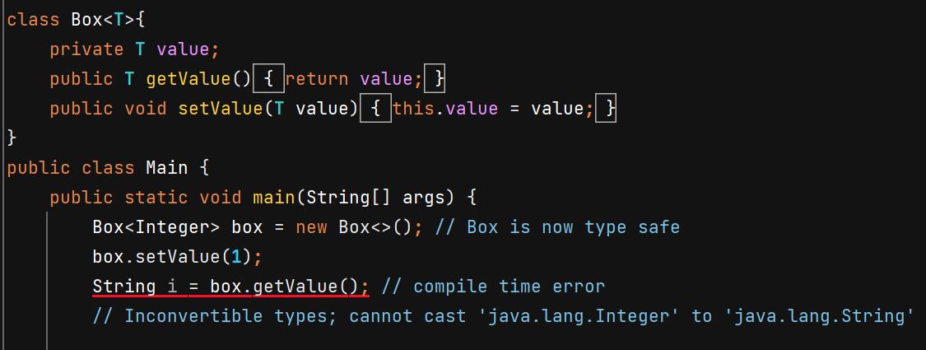

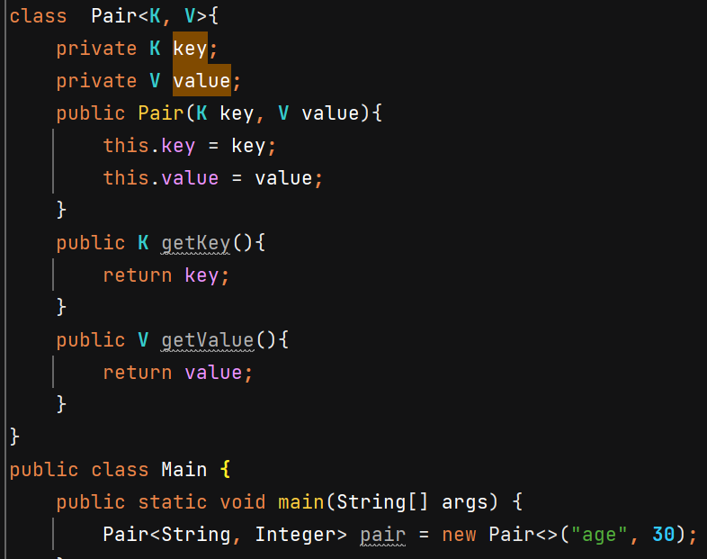

Generic Interface –

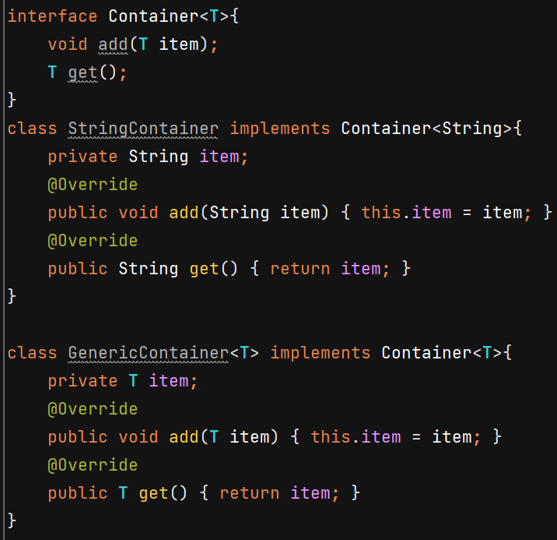

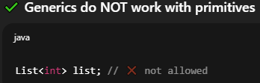

Bounded type parameters –

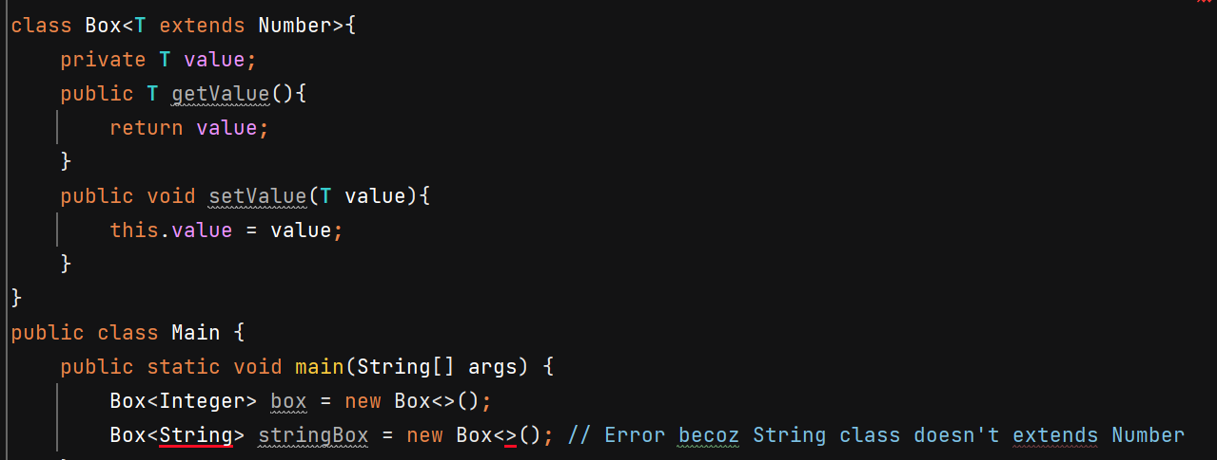

T must be **Number or any childclass of Number**.

Syntax to show multiple interfaces with extends –

Multiple bounds –

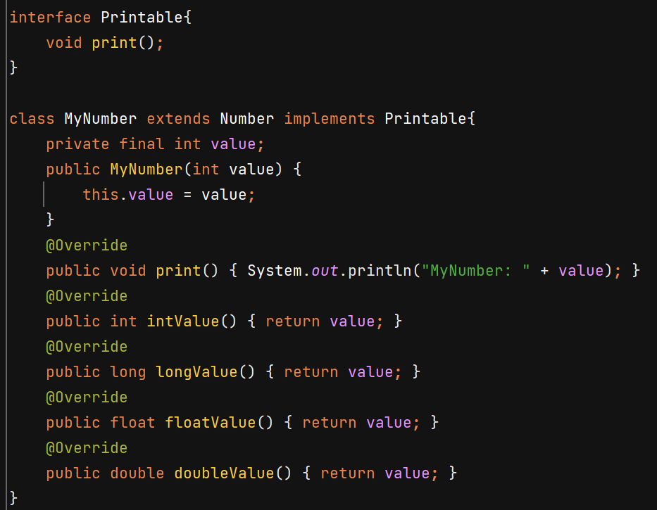

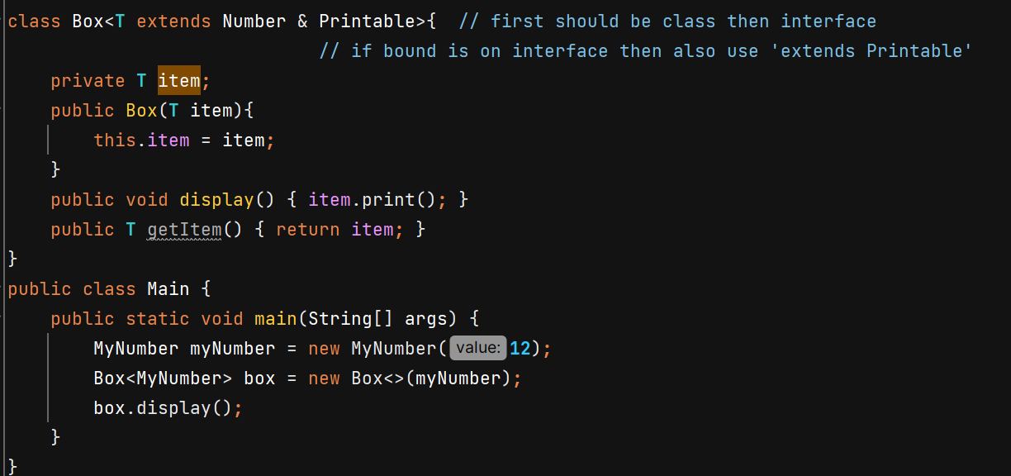

Generics in Enum 🡪 enums are already type safe

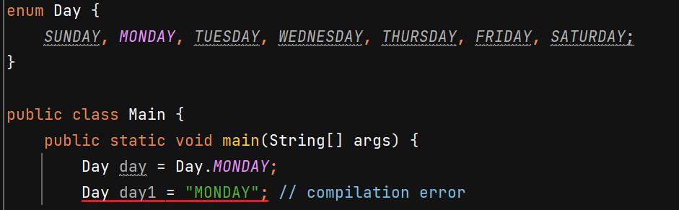

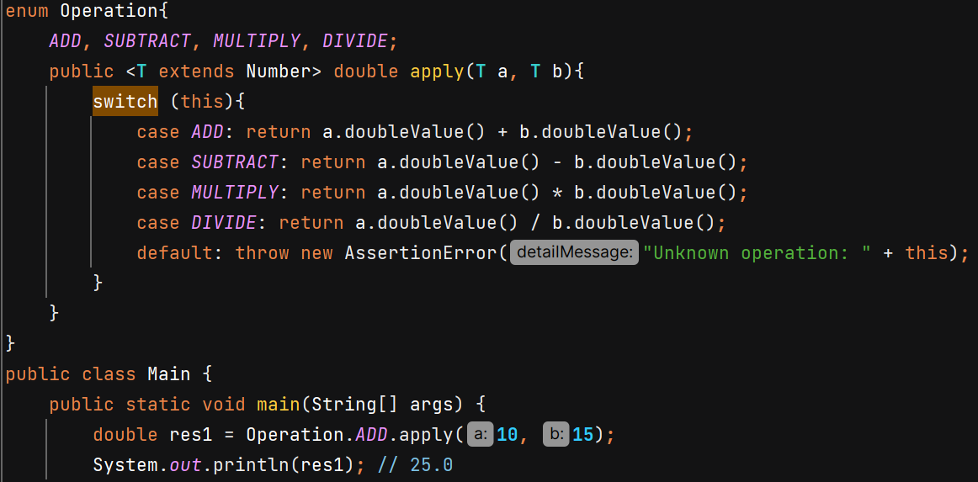

Generics Constructors – a non generic class can have generic constructor

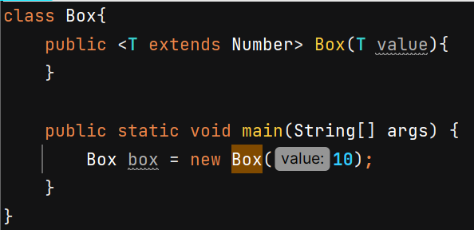

**Generic Methods** – mention <T> before return type

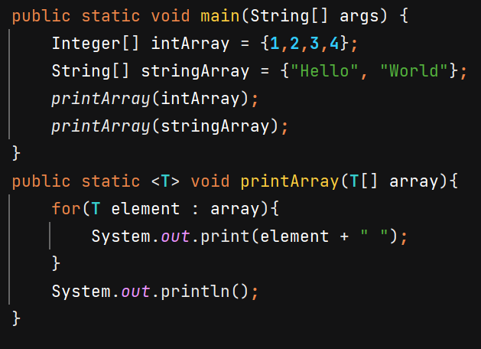

Method overloading –

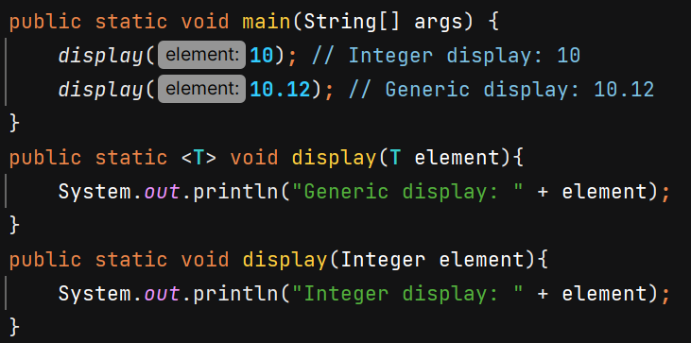 2nd is called when we pass Integer else generics one will be called.

**Wildcard –**

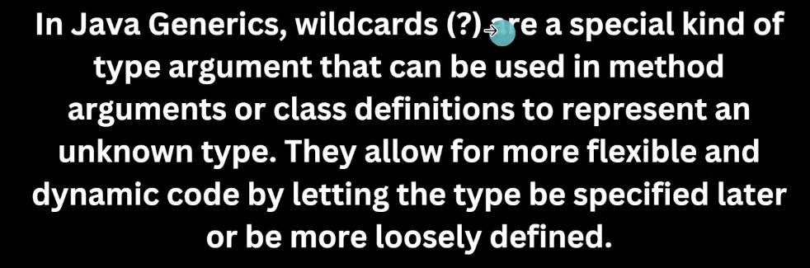

If the method is read only and does not return a value or perform any write operation, then mentioning T is not necessary and we can use ? wildcard just for simplicity.

When we return something, we’ll use T to maintain type safety.

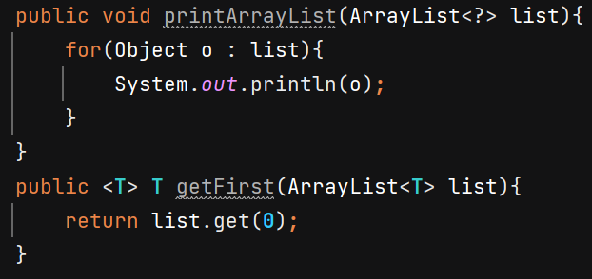

We’ll get error if doing write operation with wildcard – because with unknown type we can only read

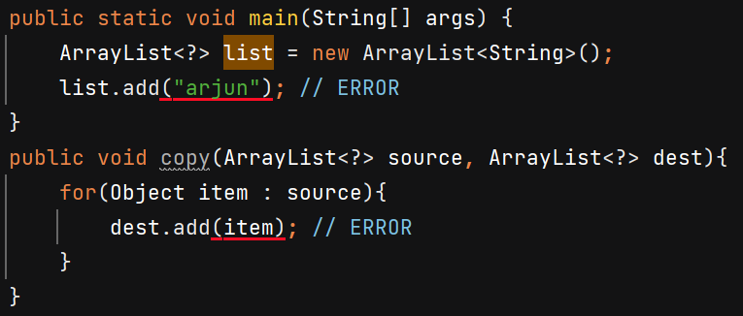

**Boundation with wildcard –**

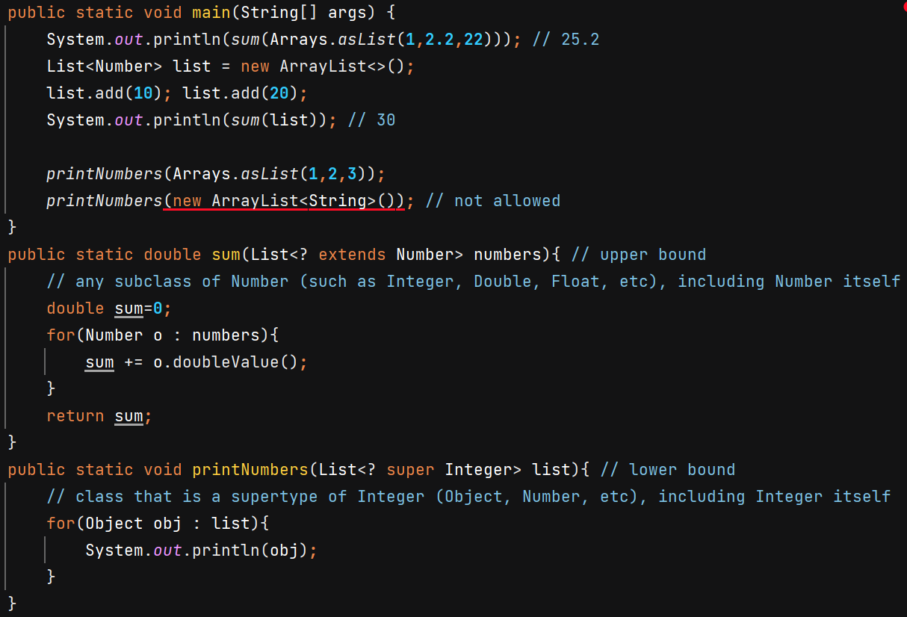

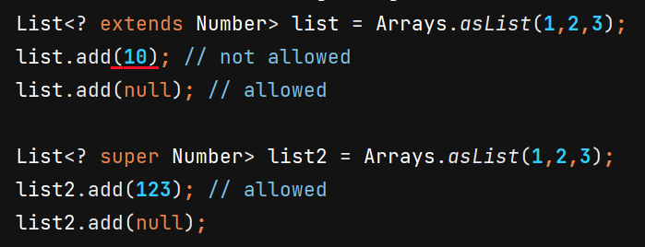

In extends we don’t know what exactly is the type that’s why it doesn’t allow to add.

**🡺 super is used only with wildcards (? super)**, not with <T>.

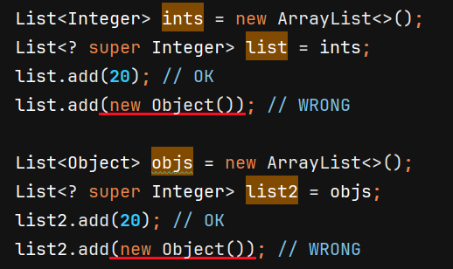 

You can only add Integer but it can hold list of any superclass of Integer or Integer itself.

Custom class with wildcard – 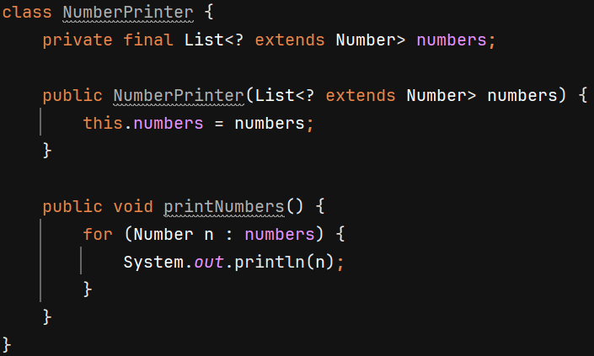

**Type Erasure** – generic type gets erased during compilation and get replaced by Object

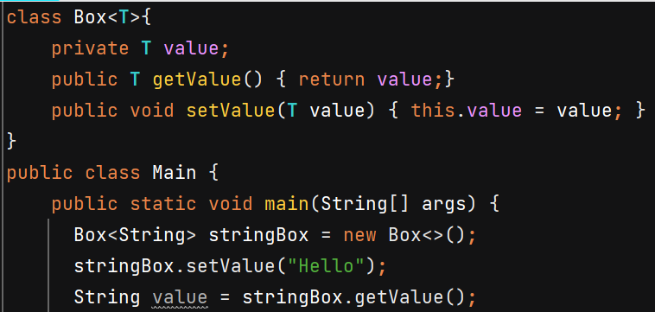

When u add value compiler will check whether u r adding String or not. But in bytecode, there are no Generics. Box<String> 🡪 the String gets erased. So, after doing type checking compiler will erase information of generics.

Internally after compilation, it will look like – 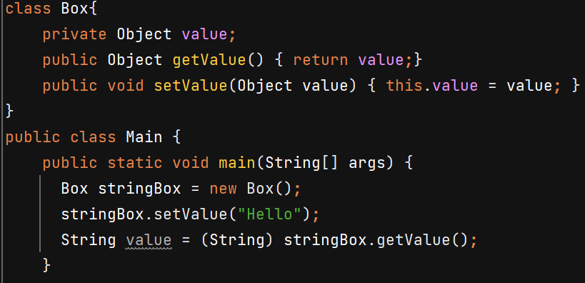

Ex2 – 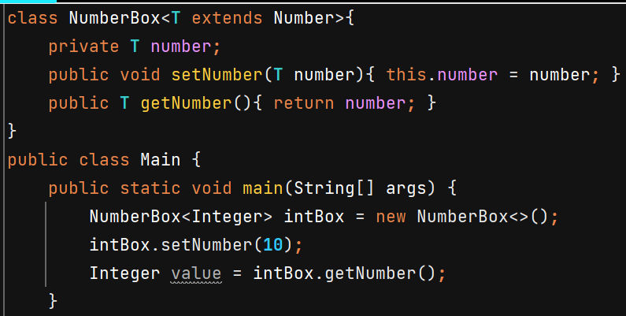

After compilation - 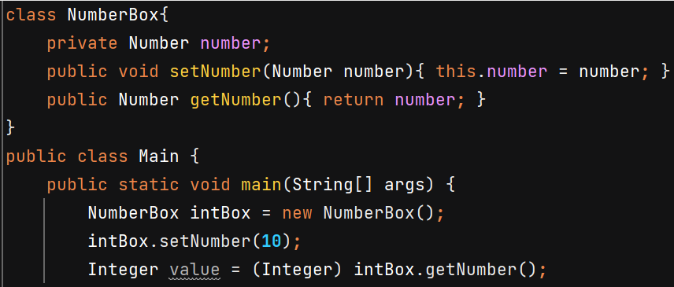

**Generics Exception -**

It becomes little bit complicated because Exceptions are thrown at runtime and at runtime there is no generic information due to type erasure but JVM needs exact type to create exception object.

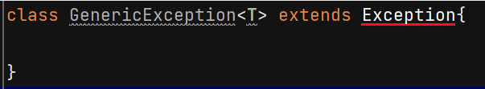 Compilation Error

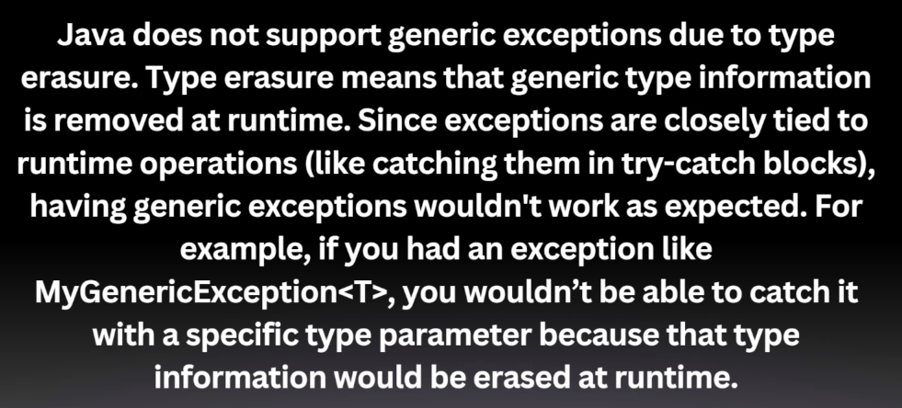

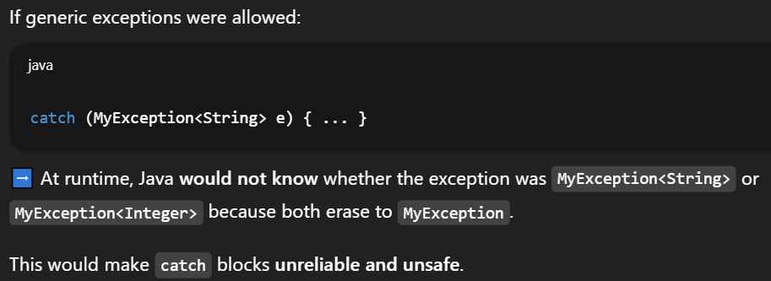

Workaround – 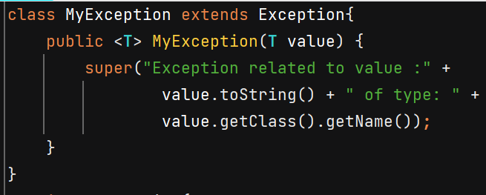

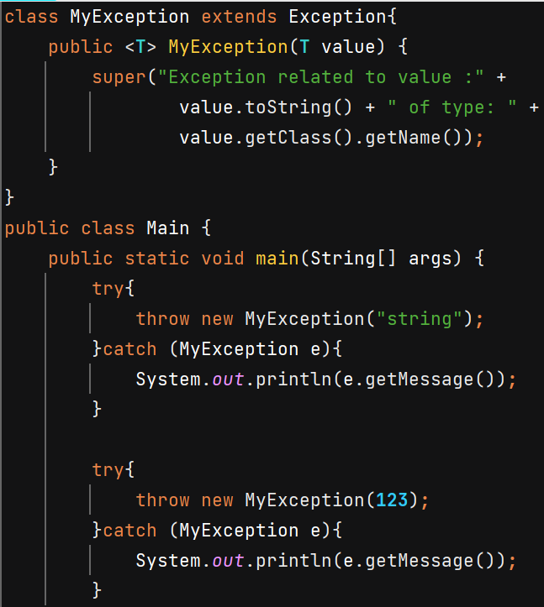

O/P 🡪 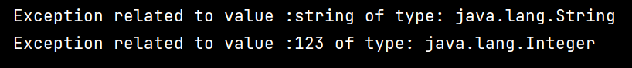

**SOLID Principles**

**Single responsibility principle** – suppose in book manager class we create methods to addbook, removebook, printbook and savebooksToFile. This voilates the principle

Book manager class should have – addBook, removeboook

Book printer class – printbook;

Filemanager class – savebookstofile

**Open close princple** – do not modify the existing code rather than extend the code.

Ex- class discount hass method calculate() which return hardcode 10% discount.

Open close -create Discount method and 2 implementation class regulardescoint and premium descount class.

Regular discount class give 10%, Premium discount class give 15%

**Liscov substitution principle** – objects of superclass should be replacable with the objects of child class without breaking the application.

Ex – class bird has fly method

Penguin class extends birdclass which override fly method and throw exception UnsupportedOperationException(“penguin can’t fly”)

Correct – create flyable interface, create birdclass, create flyingbird class which extends birdclass and impolement flyable interface.

Penguin can now extend birdclass

**Interface segregation principle** – classes should not be forces to implement interfaces it doesnot use.

Ex – interface worker has 2 method – work() and eat()

Class humanworker implement worker – implement both method

Class robot worker implement worker – implement work but throw exception for eat()

Correct – make 2 separate inereface – workable and eatable

Human worker implements both, robot worker implements only 1

**Dependency inversion principle –** high level modules(business logic) should not depend on low level modules(sub task), both should depend on abstractions.

Ex- class CreditCardPayment has pay(), class Paymentservice uses object of CreditCardPayment and inside processPayment calls its pay method.

Problem – in futue adding new payment type Is difficult as it is tighly coupled with creditcardpayment

Correct – interface payment has pay method both credicardpayment and paypalpayment class implement it and override paymethod. Now Payment can be used in PaymenService class.